1. Introduction

1.1 Immunopathology of Multiple Sclerosis

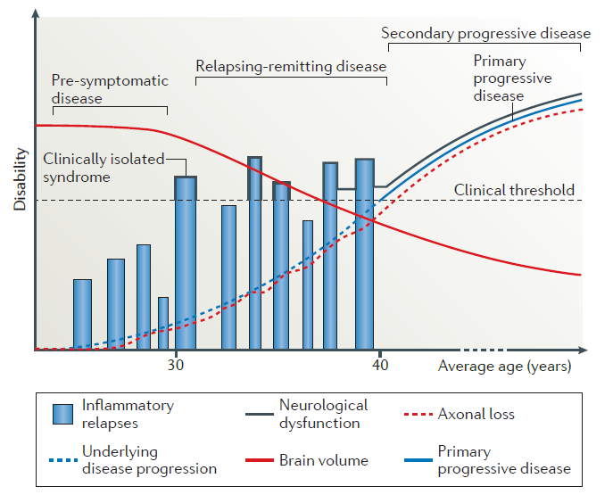
Figure 1 | Clinical and neurodegenerative progression of Multiple Sclerosis (Dendrou et al., 2015). The evolution of disability in MS across different disease stages and average patient age is illustrated. Blue bars show inflammatory relapses typical of the relapsing–remitting phase, while the curves represent neurological dysfunction, axonal loss, brain volume and underlying disease progression. The transition from the inflammatory phase (relapsing-remitting and clinically isolated) to the neurodegenerative phase (primary or secondary progressive) occurs as the clinical threshold is exceeded, marking the onset of evident symptoms and irreversible disability.

Multiple sclerosis (MS) is a chronic neuroinflammatory disease of the central nervous system (CNS) characterized by a progressive course and a substantial impact on long-term functional abilities. It represents one the leading causes of neurological disability in young adults and shows markedly higher prevalence in women (Lublin et al., 2022). Current estimates indicate that approximately 2.5 million individuals worldwide live with MS, with an average age at diagnosis of around 30 years. Despite significant therapeutic advances over recent decades, the disease continues to exert a considerable burden on patients’ quality of life: about 50% of individuals require permanent wheelchair use within 25 years of diagnosis (Dendrou et al., 2015).
From a clinical perspective, MS exhibits a wide heterogeneity of manifestations, reflecting the variability of the anatomical regions affected within the CNS. The most common symptoms include sensory disturbances, visual impairment, motor dysfunction, pain, chronic fatigue and cognitive deficits. The multifocal nature of the lesions results in an extremely diverse clinical presentation, which can differ substantially from one patient to another.
The characteristic lesions of MS arise from the infiltration of immune cells across the blood-brain barrier (BBB). This event triggers a cascade of pathological processes, including demyelination, inflammation, reactive gliosis and neuroaxonal degeneration: all of them impair neural signal transmission and contribute to the progression of disability. The disruption of BBB integrity represents a pivotal step in the pathogenesis of the disease, as it enables the entry of autoreactive lymphocytes and additional immune cell populations into the CNS, amplifying tissue damage.
Several clinical forms of MS are recognized (Figure 1):
- Clinically Isolated Syndrome (CIS) is characterized by a first neurological demyelinating episode lasting at least 24 hours. It doesn’t necessarily evolve into multiple sclerosis, but the probability of conversion depends on factors such as the presence of Magnetic Resonance Imaging (MRI) lesions;
- Relapsing-Remitting Multiple Sclerosis (RRMS) is the most common clinical presentation, accounting for approximately 85% of initial diagnoses. This clinical form is characterized by an initial episode of neurological dysfunction, followed by a period of clinical recovery, and subsequently by recurrent phases of relapse and remission. Relapses correspond to focal inflammation and demyelination in the CNS, typically detectable as white-metter lesions on MRI. RRMS can be classified as active or inactive, and with or without disability progression. This is the clinical form considered in the present study (Figure 2);
- Secondary Progressive Multiple Sclerosis (SPMS) is the evolution of RRMS. Disability progressively increases, with or without relapses across time. SPMS can be active or inactive, and progressive or non-progressive;
- Primary Progressive MS (PPMS) is characterized by a steady progression of disability from disease onset, without distinct relapses. About 15% of patients present this form. Also PPMS can be classified as active or inactive, and progressive or non-progressive.
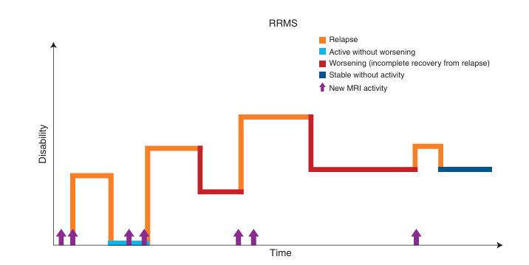
Figure 2 | RRMS: Patterns of Disease Activity and Disability Over Time (Klineova et al., 2018). This diagram shows the fluctuating course of disability in RRMS. Each color represents a disease state: orange for relapses, light blue for periods of activity without worsening, dark red for incomplete recovery following a relapse, and dark blue for stable phases without activity. Purple arrows indicate episodes of new MRI activity, reflecting subclinical disease progression.

MS is considered an autoimmune disease because self-reactive T cells appear early within developing lesions and mount aberrant responses against CNS antigens. For this reason, the infiltration of immune cells into the CNS represents the primary target of currently available MS therapies. However, despite substantial advances in immunomodulatory and immunosuppressive treatments, no drugs have yet been approved as a definitive cure for this disease.
The current cause of MS remains unknown, although it is well established that the disease develops in individuals with a genetic predisposition. Environmental factors, such as infections, sunlight exposure, viral infections, diet, pollutants and lifestyle habits also influence the likelihood of disease onset (Ward et al., 2022).
Although genetic factors account for only a portion of overall risk (30%), several loci have been consistently associated with MS across large genome‑wide association studies (GWAS). The strongest and most reproducible signal arises from the major histocompatibility complex (MHC), particularly the HLA‑DRB115:01* allele, which represents the primary genetic determinant of MS predisposition: this locus contributes substantially to disease risk by modulating antigen presentation and influencing the activation of autoreactive T cells (Ward et al., 2022).
Beyond the MHC region, more than one hundred non‑HLA loci have been identified, many of which are involved in immune regulation. The majority include genes associated with T‑cell differentiation, cytokine signaling, and innate immune pathways, such as IL2RA, IL7R, TYK2, STAT3, and TNFRSF1A.
Collectively, these variants highlight the central function of immune dysregulation in MS pathogenesis and suggest that both innate and adaptive immune mechanisms contribute to disease vulnerability.
Although these loci increase the probability of developing MS, their individual effects are modest, and genetic predisposition alone does not fully explain disease onset, indicating that non-genetic contributors play a substantial role.
Because no single exogenous risk factor has yet been clearly identified, it remains an open question whether the initial trigger of MS originates in the periphery or within the CNS itself.
MS pathology is characterized by demyelinated areas in the grey and white matter of the spinal cord and brain that are called lesions and that indicate a loss of myelin sheaths and oligodendrocytes (Figure 3). At first neurons and axons are preserved in early MS, but ongoing disease results in gradual neuroaxonal loss that correlates with the disability of the patient. In the white matter, demyelinated areas can be partially repaired by remyelination. Inflammation is always present in MS, but compared to chronic phases, it is more pronounced in acute phases.
Macrophages and microglia remain in a chronic state of activation throughout the disease.
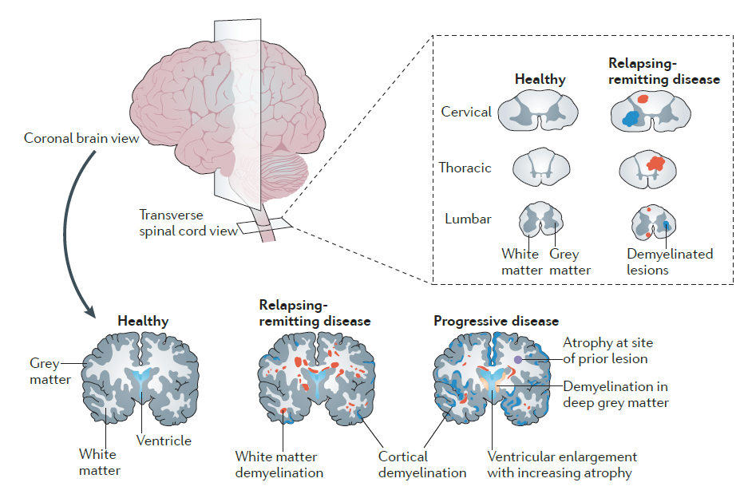
Figure 3 | Pathological Changes in Brain and Spinal Cord During Multiple Sclerosis Progression (Dendrou et al., 2015). This scheme compares healthy brain and spinal cord tissue with those affected by progressive and RRMS. The upper panel shows transverse spinal cord view highlighting demyelinated lesions (in red) across cervical, thoracic, and lumbar levels. The lower panel shows coronal brain sections: (i) In healthy tissue, grey and white matter appear intact; (ii) In RRMS, cortical demyelination and focal white matter are evident; (iii) In progressive MS, atrophy, ventricular enlargement, and deep grey matter demyelination reflect chronic neurodegeneration.
All these changes show the transition from localized inflammatory lesions to diffused neurodegenerative damage characteristic of advanced MS.

Potentially through molecular mimicry (Figure 4), autoreactive T cells may become activated in peripheral tissues and subsequently migrate toward the CNS together with monocytes and B cells, as described in the CNS‑extrinsic model (Dendrou et al., 2015). This model mirrors the approach used to induce experimental autoimmune encephalomyelitis (EAE), the MS‑like disease in mice, in which emulsified CNS antigens are administered alongside immune stimulants. This procedure leads to the generation of pathogenic CD4⁺ Th1 and CD4⁺ Th17 cells within lymph nodes. These activated lymphocytes then enter the bloodstream and ultimately exert their effector functions inside the CNS, crossing either the BBB or the blood–cerebrospinal fluid barrier at the choroid plexus.
Although the precise cause of MS remains unknown, findings from EAE studies suggest that the disease may be triggered by the activation of autoreactive T cells through an external factor, such as a viral infection (e.g., Epstein–Barr virus), via the mechanism of molecular mimicry.

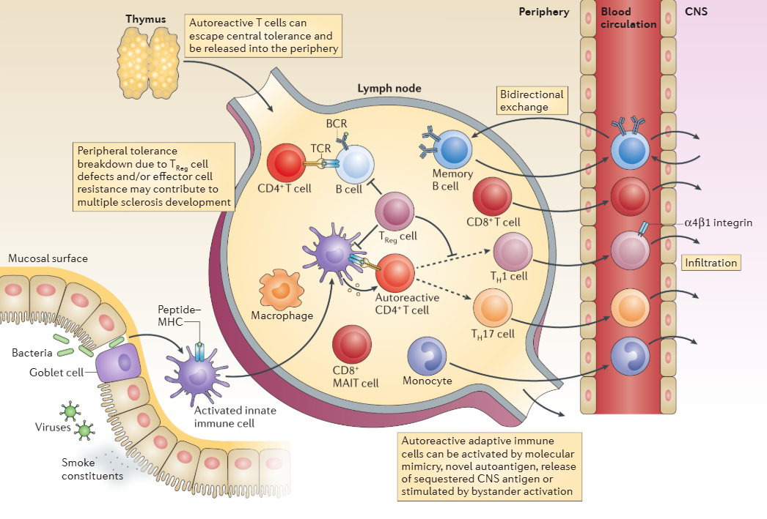
Figure 4 | Immunopathogenesis of MS: Breakdown of Immune Tolerance and CNS Infiltration (Dendrou et al., 2015). The immunological mechanisms underlying the development of MS are illustrated. The diagram shows how autoreactive T cells can escape central tolerance in the thymus and enter the periphery, where defective regulatory T (Treg) cells and effector cell resistance lead to a breakdown of peripheral tolerance. Into the lymph node, immune cells like CD4⁺ and CD8⁺ T cells, B cells, macrophages, and monocytes, interact and become activated through molecular mimicry, novel autoantigens, or bystander activation. These autoreactive cells then migrate through the bloodstream, cross into the CNS via α4β1 integrin–mediated infiltration, and contribute to demyelination and neuroinflammation. Environmental triggers such as viruses, bacteria, and smoke constituents at the mucosal surface may stimulate immune activation.

Activated IFN-γ-producing Th1 cells and IL-17-producing Th17 cells infiltration into the CNS stimulates an inflammatory cascade which is followed by increased permeability of BBB and recruitment of B cells and macrophages. Autoreactive B cells enter the CNS where they can produce autoantibodies against myelin and induce macrophages cytotoxic reactions to attack the myelin sheath and cause axonal loss and progressive neurodegeneration.

1.2 The role of the gut microbiota in Multiple Sclerosis

In recent years, studies have revealed that bacteria, viruses and fungi which comprise the large community of microorganisms that populate the gut, i.e. the gut microbiota, influences systemic immune responses. “Core microbiome” of healthy people is the optimal composition of gut that is known as eubiosis: this condition reflects the right equilibrium of gut microbiota, and it is required to maintain gut homeostasis and host health (Correale et al., 2022). However, this state could be modified in several states of disease. When this equilibrium is disrupted, there is a condition of alteration in microbial composition and function called dysbiosis (Figure 5).
The gut microbiota is also important as it can produce metabolites, which are the product of the process of its metabolism. When a molecule is assimilated by the organism, it undergoes transformation, becoming more absorbable or eliminated: at this point it is called a metabolite.
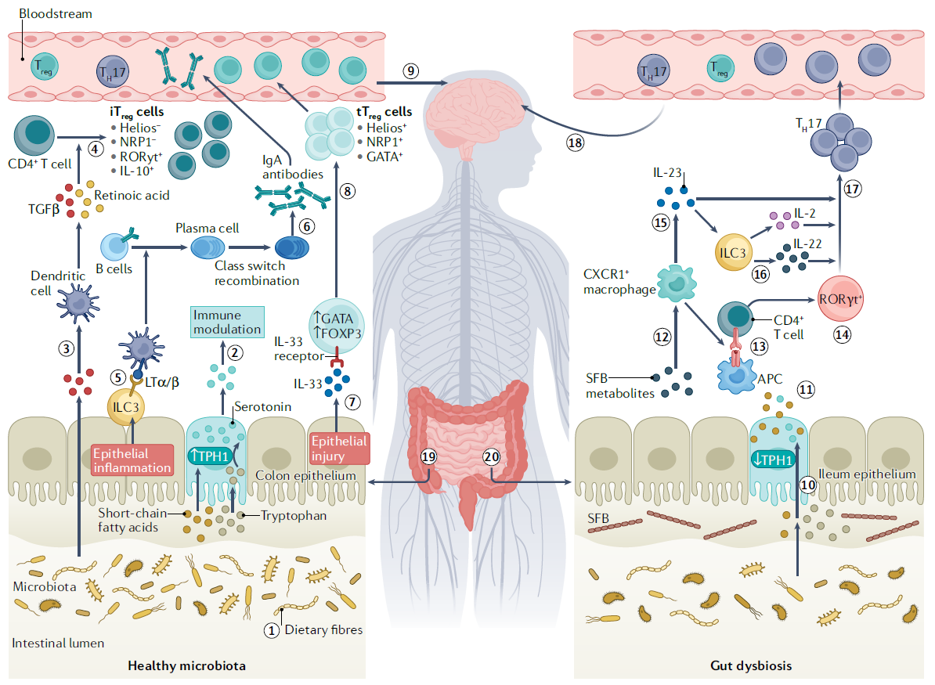
Figure 5 | Gut–Brain–Immune Axis in Multiple Sclerosis (J. Correale et al., 2022). The figure shows how gut microbiota influences immune regulation and neuroinflammation in MS. A healthy microbiota supports epithelial integrity and Treg cell induction, while gut dysbiosis promotes Th17 activation, cytokine release, and CNS inflammation, causing brain immune responses.

Analyzing the figure illustrating the role of the gut microbiota in maintaining immune homeostasis and in the development of autoimmune processes, the left panel shows that, under conditions of eubiosis, a healthy microbiota promotes immune tolerance through the production of metabolites such as short‑chain fatty acids and tryptophan derivatives. These signals modulate the activity of dendritic cells and ILC3 (Type 3 innate lymphoid cells), promoting the differentiation of regulatory T cells (Treg) and supporting IgA production, both essential for preserving mucosal barrier integrity.
Conversely, the right panel depicts the dysbiotic state, characterized by alterations in microbial composition, such as an increase in segmented filamentous bacteria (SFB), which triggers pro‑inflammatory immune pathways. Antigen‑presenting cells (APCs) drive the polarization of CD4⁺ T cells toward a Th17 phenotype through cytokines including IL‑6, IL‑23, and IL‑22, leading to amplification of systemic inflammatory responses and epithelial damage.
The gut-associated lymphoid tissue (GALT) is the tissue that represents the immune system of the digestive tract. It is responsible for the protection of mucosal from attacks by pathogens. It is important to remember that the gastrointestinal system is a communication way with the outside and the intestine appears to be populated by potentially pathogenic microorganisms: the necessary role of the GALT is precisely that of presenting a strong immune system that guarantees the control of these populations (Figure 6).
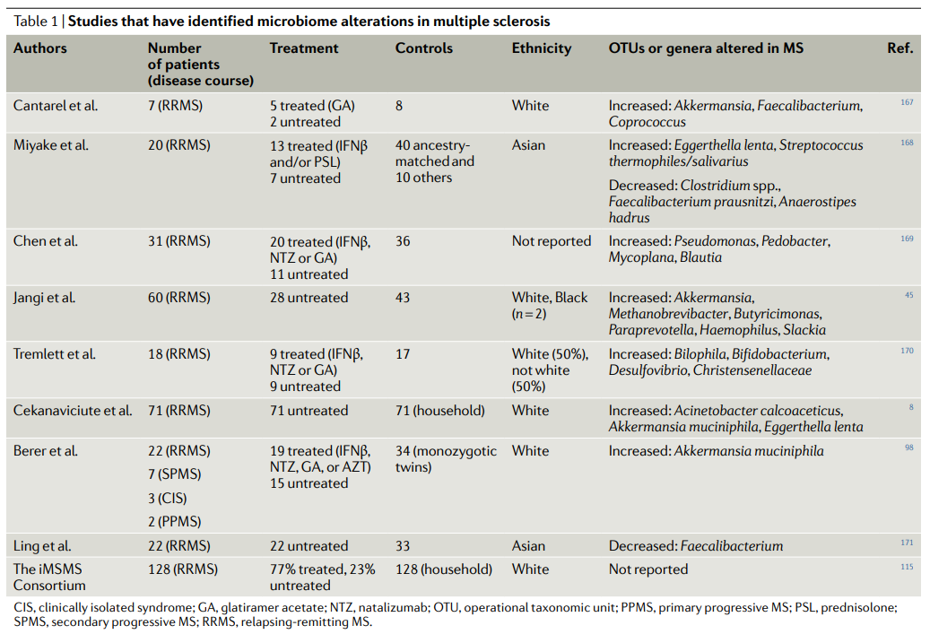
Figure 6 | Studies about gut microbiome alterations in MS (J. Correale et al., 2022). This table shows major studies investigating gut microbiota changes in MS. Across studies, genera such as Akkermansia and Faecalibacterium frequently appear modified, suggesting an association between immune dysregulation and microbial dysbiosis in MS.

Some bacteria promote the activation of anti-inflammatory immune system cells in the GALT such as Treg cells, while others promote a pro-inflammatory state. This action of the gut microbiota on the immune system is also involved in the gut-brain axis (Mayer et al., 2022). Researchers define gut-brain axis as a bidirectional communication between the gut and CNS through microbiota.
Thanks to the enteric neural innervation and the vagus nerve, the brain influences the physiological activities of the gut and the mucosal immune system’s development. In contrast, the gut can influence the CNS through intestinal microbiota, its metabolites and gut immune cells influencing brain function. Recent findings on dysbiosis in MS patients seems to confirm this gut-brain connection (Figure 7).
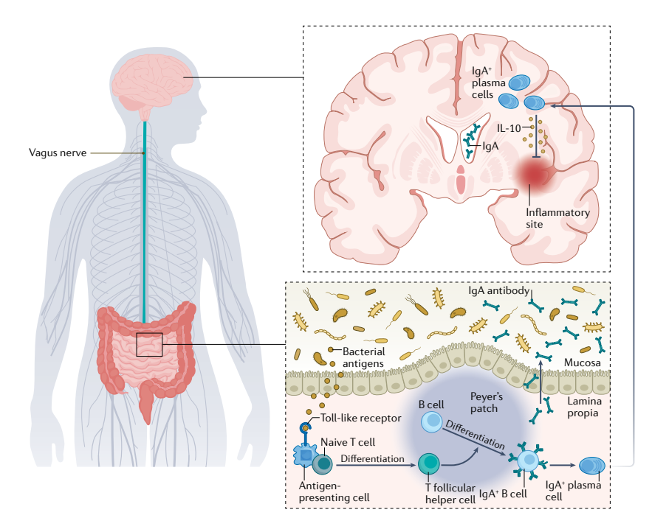
Figure 7 | Gut–Brain Immune Communication (J. Correale et al., 2022). The gut–brain axis mediated by IgA-producing immune cells is represented. In the gut, bacterial antigens activate antigen-presenting cells and B cells in Peyer’s patches, leading to IgA⁺ plasma cell differentiation. These cells secrete IgA that help maintain mucosal balance. Through the vagus nerve, immune mediators and signals influence the CNS, where IL-10 and IgA⁺ plasma cells contribute to anti-inflammatory responses at neuroinflammation sites.

The dysbiosis observed in MS patients appears to be responsible for a pro-inflammatory switch of the immune system which is actually typical of the immune system of pathological patients. This explains the reason why systemic and gut immunity as gut microbiota are perturbed in MS.
The gut microbiota effect on MS progression has been demonstrated in EAE mice: the intestinal microbiota can regulate the BBB permeability, myelin related genes expression, and microglial activation, especially by secreting metabolites and bacterial antigens, as I mentioned before.
Nowadays, to prevent new attacks and to reduce relapses associated with worsening, different disease-modifying treatments (DMTs) are available (M. Amin et al., 2023).
They differ from points of view of efficacy and effects to slow neurodegeneration.
For now, corticosteroids are the primary treatment for acute relapses, but their effect on microbiota is still unknown.
It was already studied how gut microbiota differ between healthy subjects and patients with MS, suggesting an important role of gut microbiota in the disease's pathology.
Also the type of therapy may influence the microbiota: DMTs can alter its composition, meaning that in part their effectiveness depends on the beneficial impact on microbial balance (S. Pilotto et al., 2023).
The aim of this study is to analyze the gut microbiota of patients affected by multiple sclerosis and undergoing specific therapies, with the aim of identifying which microorganisms may serve as markers of the disease and assessing how these microbial components change over time.

1.3 Gut Microbiota Alterations: Bacterial Species Associated with MS
Alterations of the gut microbiota in patients with MS are continuously investigated and updated.
Several papers analyze how the intestinal microbiota may contribute to MS pathogenesis through interactions with the immune system, metabolism, and the CNS.
It is well established that MS is influenced by both genetic and environmental factors; since the microbiota is a modifiable factor, it is potentially useful for developing new therapeutic strategies.
Frequently, people with MS display altered gut microbiota, characterized by depletion of fiber‑fermenting, SCFA‑producing commensals, and expansion of taxa associated with mucus degradation and pro‑inflammatory metabolism (A. Sanchez‑Sanz et al., 2026).
Microbial metabolites reach the CNS through the bloodstream, in particular:
- SCFAs modulate microglial maturation and inflammatory tone;
- tryptophan metabolites regulate microglia and astrocytes;
- kynurenine leads to the accumulation of neurotoxic metabolites.
Moreover, the microbiota modulates systemic and intestinal immune responses, causing:
- an increase in Th1/Th17 cells in patients;
- a reduction in Treg cells and IL‑10;
- possible molecular mimicry between microbial peptides and myelin antigens.
In humans, alterations in IgA⁺ B cells specific for the microbiota, which can migrate into the CNS, are also known.
Several studies describe a recurring ecological pattern, rather than a single pathogen.
Among the reduced taxa are Roseburia spp., Prevotella spp., Bacteroides, Parabacteroides, Eubacterium spp., and Anaerostipes. These are anti‑inflammatory commensals producing SCFAs (A. Sanchez‑Sanz et al., 2026).
These bacteria are involved in butyrate production, fiber degradation, and maintenance of the intestinal barrier.
Specifically in P. Rasoulian et al. (2025), a significant reduction of Bacteroides fragilis has been reported (Figure 8) compared with healthy controls (0.11 × 10⁹ vs. 0.22 × 10⁹ CFU, p<0.05). This is highly relevant because B. fragilis produces polysaccharide A, which stimulates Treg cells and exerts anti‑inflammatory effects (P. Rasoulian et al., 2025).
Bifidobacterium spp. are also significantly lower in MS patients (Figure 8) compared with healthy subjects (1.50 × 10⁹ vs. 1.65 × 10⁹ CFU, p=0.04) in the same study.
These bacteria are essential for intestinal barrier integrity, SCFA production, and modulation of the gut–brain axis. Their reduction suggests a possible contribution to early immune dysfunction (P. Rasoulian et al., 2025).
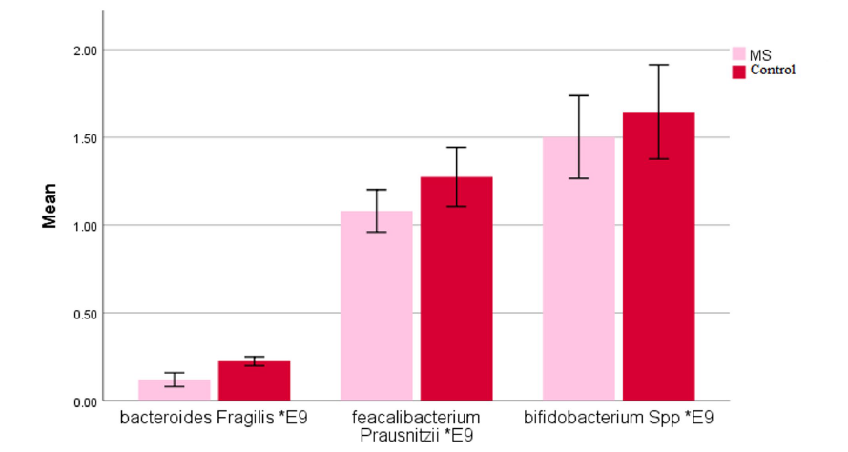
Figure 8 | Gut Microbiota Abundances in MS vs Controls (P. Rasoulian et al., 2025). Comparison of mean bacterial abundances (×10⁹ CFU) of Bacteroides fragilis, Faecalibacterium prausnitzii, and Bifidobacterium spp. in MS (pink bars) and healthy controls (red bars). Error bars represent standard deviation.

Scientific literature also reports a decrease in Faecalibacterium prausnitzii (Figure 8), although not statistically significant (1.08 × 10⁹ vs. 1.27 × 10⁹ CFU, p=0.06). However, the trend is relevant because this species is one of the main butyrate producers, a metabolite with strong anti‑inflammatory activity (P. Rasoulian et al., 2025).
Conversely, an increase in pro‑inflammatory, mucin‑degrading taxa is well documented (Figure 9): Akkermansia muciniphila, Ruminococcus gnavus / torques, Eggerthella lenta, Collinsella aerofaciens, Blautia spp., Streptococcus spp., Tyzzerella nexilis (A. Sanchez‑Sanz et al., 2026).
A robust microbial marker has also been investigated: the Bifidobacterium adolescentis : Akkermansia muciniphila ratio (BA:AM), which is reduced in MS patients.
Additionally, these patients show Blautia species as microbial community drivers, whereas healthy controls display Prevotella copri (S. Ghimire et al., 2025).
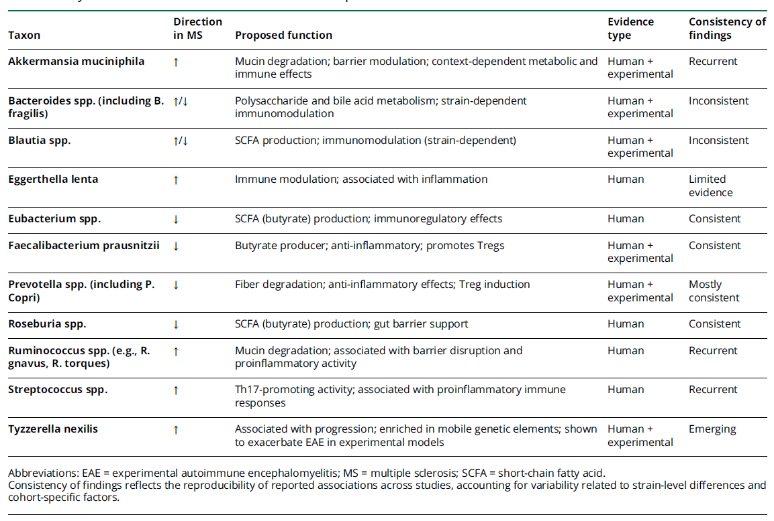
Figure 9 | Key Gut Bacterial Taxa Associated With Multiple Sclerosis (A. Sanchez‑Sanz et al., 2026). Summary of intestinal microbial taxa altered in multiple sclerosis patients, indicating the direction of change, proposed biological functions, and supporting evidence from human and experimental studies.

1.4 Therapies: Mavenclad and Tecfidera
In this thesis, two therapies are discussed: Mavenclad and Tecfidera.
The clinical efficacy of the treatments under consideration will not be examined in detail; however, before proceeding with the analysis of the data, it is necessary to clarify several fundamental aspects regarding the two therapies being compared.
As previously cited, there is currently no definitive cure for MS. However, several long‑term DMTs proved effective in reducing inflammatory activity and preventing clinical deterioration. Within this therapeutic landscape, Mavenclad and Tecfidera represent two pharmacological options with markedly different characteristics, mechanisms of action, and administration regimens.
Mavenclad contains cladribine as its active substance, a selective immunosuppressant indicated for adult patients with highly active RRMS (G. Giovannoni et al., 2022).
The distinctive feature of this therapy lies in its temporal structure: the complete treatment spans two years and consists of two short courses of administration, separated by a twelve‑month interval. Each course requires the intake of the drug for only a few days, and clinical efficacy typically extends into the two subsequent years without the need for additional dosing (Figure 10).
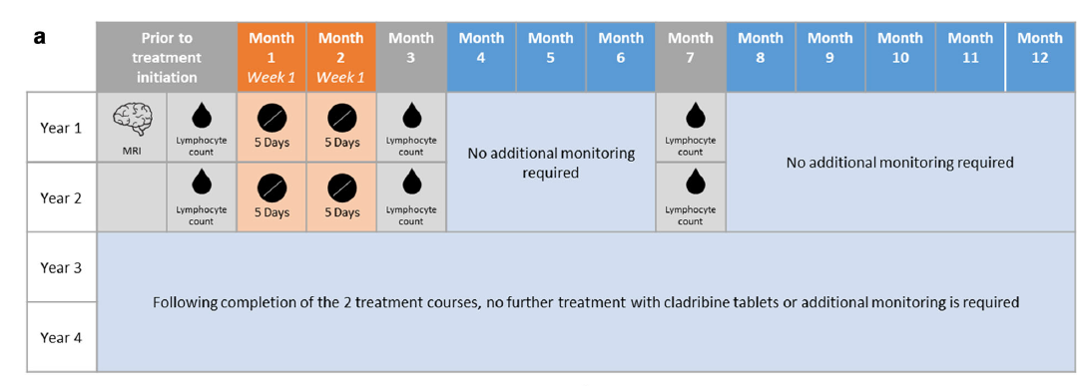
Figure 10 | Cladribine Treatment Schedule for MS patients (G. Giovannoni et al., 2022). This scheme shows the four-year treatment protocol for cladribine tablets. The timeline includes two annual courses (Year 1 and Year 2), each consisting of two 5‑day treatment cycles followed by lymphocyte count monitoring at specific intervals.

The total recommended dose, corresponding to 3.5 mg/kg of body weight, is determined by the neurologist based on the patient’s weight, ensuring an individualized therapeutic approach. Mavenclad therefore represents a highly targeted intervention (Figure 11), characterized by a significant immunological impact and a limited treatment duration.
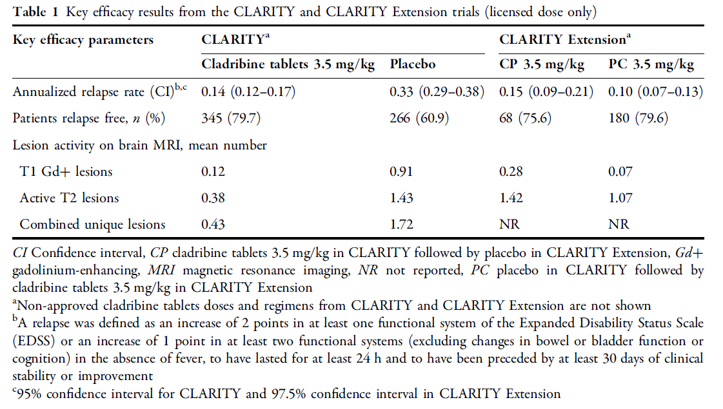
Figure 11 | Efficacy Outcomes of Cladribine Tablets from the CLARITY and CLARITY extension trials (G. Giovannoni et al., 2022). This table summarizes the key efficacy results of cladribine tablets compared with placebo. Cladribine significantly reduced the annualized relapse rate, increased the proportion of relapse‑free patients, and lowered MRI lesion activity.

Specifically, Cladribine is a nucleoside analogue of deoxyadenosine, designed to selectively interfere with DNA synthesis in immune cells with high proliferative activity. This property makes it particularly effective in modulating the lymphocyte populations involved in the autoimmune mechanisms of multiple sclerosis. The oral formulation allows for intermittent administration, which is characteristic of Immune Reconstitution Therapy (IRT).
Indeed, Cladribine tablets represent a well‑established model of IRT, a therapeutic strategy based on short treatment cycles during the first two years, capable of inducing a profound lymphocyte depletion followed by a qualitatively different immune reconstitution. This process of immunological “reset” underlies the prolonged remission observed in patients with multiple sclerosis.
The drug exerts marked lymphocyte selectivity, with at least a 90% depletion of total and memory B cells and an approximately 50% reduction in T cells. The impact on memory B cells, central to the persistence of autoimmune activity, is one of the key elements of its mechanism of action. Moreover, Cladribine tablets penetrate the CNS. The immune reconstitution that follows the depletion phase does not simply restore the previous profile, but generates a more stable immune system, less prone to autoimmune activity. Emerging data confirm sustained efficacy over time, with reduced relapse rates and radiological stabilization (G. Giovannoni et al., 2022). Clinical management requires lymphocyte monitoring, assessment of infectious risk, and appropriate planning of redosing.
In summary, Cladribine tablets represent an effective and innovative oral therapy capable of deeply yet selectively modulating the immune system, providing a prolonged remission profile consistent with the IRT model.
In contrast, Tecfidera is a first‑line therapy whose active substance is dimethyl fumarate. It is an immunomodulatory agent administered orally on a daily basis and is indicated for adult patients with RRMS, particularly as an initial treatment option. The therapy requires a gradual dose escalation during the first weeks to improve tolerability and reduce early gastrointestinal side effects, which are relatively common at treatment initiation (O. Fernández et al., 2017).
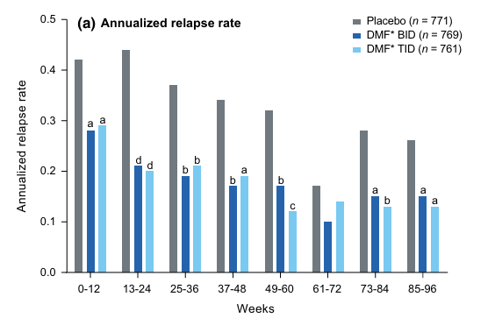
Figure 12 | Effect of Dimethyl Fumarate (DMF) on Annualized Relapse Rate (O. Fernández et al., 2017). This graph compares the annualized relapse rate in MS patients treated with DMF twice daily (BID) or three times daily (TID) versus placebo for 96 weeks. Both regimens show lower relapse rates than placebo, with sustained efficacy over time.

Unlike Mavenclad, Tecfidera is a chronic therapy: it has no predefined end date and is continued as long as it remains effective in controlling disease activity and is well tolerated by the patient (Figure 12).
In some cases, however, the clinical response may be suboptimal; in such circumstances, patients may transition to more selective and potent therapies such as Mavenclad.
Nonetheless, therapeutic guidelines generally recommend initiating treatment with first‑line agents, which are less intensive and have a well‑established safety profile, reserving high‑efficacy therapies for cases in which the disease exhibits more aggressive features or fails to respond adequately to initial treatment.
In summary, Mavenclad and Tecfidera represent two distinct therapeutic strategies in the management of RRMS: the first one is characterized by a selective immunological intervention with a time‑limited regimen, while the second one provides continuous immunomodulation over an extended period. These characteristics are important for accurately interpreting clinical data and contextualizing the analysis of each patient.
An interesting remark concerns these therapies: in addition to modulating immune activity in MS, they also influence susceptibility to latent viral infections such as herpes zoster, showing different risk profiles that reflect their specific mechanisms of action (Figure 13).
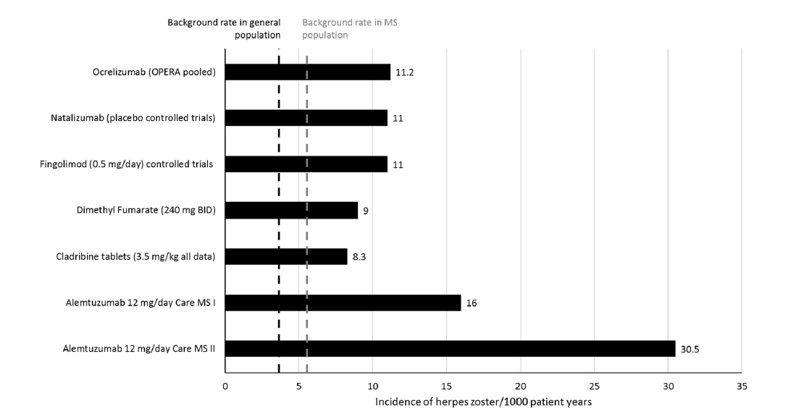
Figure 13 | Incidence of Herpes Zoster (HZ) in MS Treatments (G. Giovannoni et al., 2022). Both cladribine (8.3 cases/1000 patient‑years) and dimethyl fumarate (9 cases/1000 patient‑years) show lower infection rates than other high‑efficacy treatments such as alemtuzumab (30.5 cases/1000 patient‑years). These data highlight the favorable safety profile of cladribine and dimethyl fumarate regarding viral reactivation risk.

The dashed lines indicate the baseline incidence in the general population (black) and in the MS population (grey). All treatments show an incidence above the baseline, with higher values for Alemtuzumab, whereas Cladribine and Dimethyl fumarate display a relatively lower risk (G. Giovannoni et al., 2022).
For Cladribine (3.5 mg/kg), an HZ incidence of 8.3 per 1000 patient‑years is observed, slightly higher than the MS background rate. This risk is linked to the transient lymphocyte depletion, particularly of B and T cells, but tends to normalize in the months following the treatment cycle. Antiviral prophylaxis is not routinely required, although it is recommended in patients with marked lymphopenia.
For Dimethyl fumarate (240 mg BID), an incidence of 9 per 1000 patient‑years is observed, comparable to Cladribine. Its immunomodulatory effect is mainly driven by the reduction of CD8⁺ lymphocytes and the activation of the Nrf2 pathway, resulting in a moderate and generally manageable infectious risk.
Although both therapies show an increase compared with the general population, they maintain a favorable safety profile relative to high‑efficacy treatments such as Alemtuzumab (I. Del Negro et al., 2023), where lymphocyte depletion is deeper and more prolonged.

Aim
The aim of this thesis is to investigate how the gut microbiome profile at diagnosis and throughout the clinical follow-up can identify microbial signatures associated with radiological and clinical features of multiple sclerosis, potentially providing additional diagnostic information. This objective is grounded in the growing evidence that the intestinal microbiota plays a relevant role in neuroimmunological diseases, influencing immune regulation, inflammatory pathways, and possibly the clinical trajectory of multiple sclerosis.
To address this aim, the patient cohort was divided according to the disease-modifying therapies described in the previous chapter, distinguishing individuals treated with different pharmacological approaches. Although multiple therapies are represented within the dataset, the present work focuses primarily on the group of patients receiving Tecfidera, whose longitudinal clinical course is evaluated over a predefined one-year follow-up. This follow-up period allows for the assessment of potential clinical changes and radiological evolution, while also enabling the detection of microbiota variations that may emerge over time. The therapeutic details of Tecfidera have been extensively discussed in the preceding section; therefore, in this chapter it is referenced only as the treatment framework within which the microbiome–clinical associations are explored.
By integrating clinical and radiological follow-up data with microbiome profiling, this thesis aims to determine whether specific microbial signatures can be identified at diagnosis and whether their evolution over time correlates with disease activity, treatment response, or radiological progression. The central hypothesis is that gut microbiota composition may reflect or anticipate clinically relevant changes, thereby offering complementary diagnostic insights that could support patient stratification and early identification of individuals at risk of disease progression.
This combined clinical–microbiological approach provides a comprehensive framework for understanding the interplay between multiple sclerosis and the gut microbiome, contributing to the broader effort to identify biomarkers capable of improving diagnostic accuracy and guiding personalized therapeutic strategies.

2. Materials and Methods
2.1 Subjects recruitment
Subjects were recruited at four different centres: A.O.U. San Luigi Gonzaga, Orbassano (TO), Italy; Molinette Hospital, Torino, Italy; ASST Spedali Civili di Brescia, Montichiari, Italy; A.O.U. Policlinico Federico II, Napoli, Italy.
All the patients included in this study were able to express informed consent to the processing of personal data and to store biological samples.
2.2 Assessment of clinical parameters
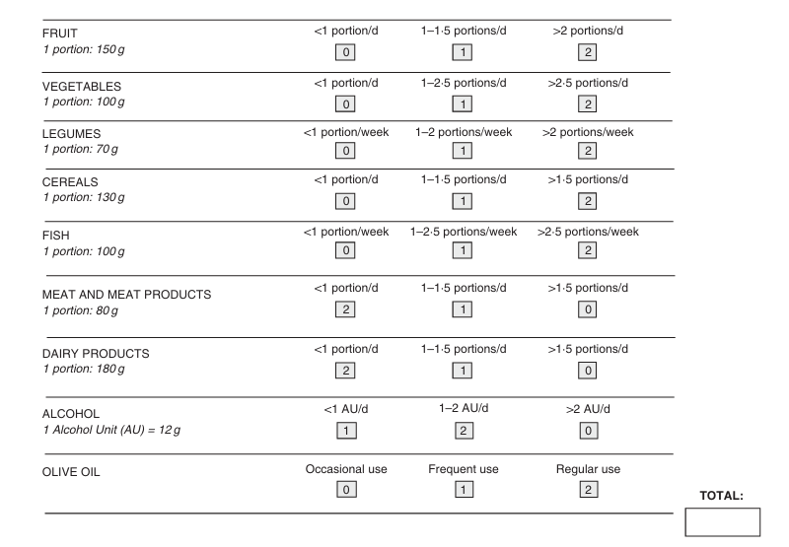
Figure 14 | Structure of MEDAS questionnaire (F. Sofi et al., 2013). Summary of the scoring criteria assigned to key dietary components used to evaluate adherence to the Mediterranean diet pattern.
At diagnosis clinical and demographics parameters were collected. Considered demographics parameters are age at baseline, sex, body index mass (BMI), MEDAS (Mediterranean Diet Adherence Score, Figure 14) (F. Sofi et al., 2013), while clinical parameters are lesion burden at baseline (threshold of ten lesions), spinal cord lesions, subtentorial lesions, use of gadolinium contrast.
The radiological activity was described as new MRI lesions, both symptomatic and not, during the follow-up.
Relapses are defined as new neurological symptoms lasting at least 24 hours and they are monitored during the period of follow-up.
An important variable is EDSS (Expanded Disability Status Scale, from 0 to 10) which is always monitored during follow-up to discover eventual worsening (0.5 increments) in disability (J. F. Kurtzke et al., 1983).
To define patients exposed or not to steroids, also glucocorticoid exposure was recorded upon entering the study.
Finally, disease worsening was defined as one or more of: increase in EDSS score of at least 0.5, new MRI lesions or new relapse events into 1 year.
2.3 Faecal sample collection
All patients were provided with specific stool sample collection kits. They were instructed to self-collect the samples (I. Ferrocino et al., 2018) and all materials were provided in a convenient specimen collection kit. All of them collect the faeces in sterile containers (25 ml faecal containers, with label and spoon, catalogue #:LPIT109147, VWR, Milan, Italy). Biological samples were collected at patients’ homes, transferred into sterile containers and immediately stored at 4°C.
The specimens were transported to the laboratory after 8 hours of collection at refrigerated temperature. At this point, containers were immediately stored at -80°C for DNA extraction. Stool samples from external centres were shipped frozen with dry ice and then all samples were processed at the Neuroimmunology Laboratory at San Luigi Gonzaga in Orbassano.
2.4 DNA extraction from stool and shotgun metagenomics sequencing
Frozen biological samples were processed through the QIAmp PowerFecal Pro DNA Kit (Qiagen, catalogue: #51804). The purity and quantity of DNA samples were measured by NanoDrop 1000 (Thermo Scientific ™).
At this point DNA samples were sent to UK for Shotgun Metagenomics Sequencing (Illumina sequencing PE150, 9 Gb raw data per sample).


Figure 14 | Workflow of DNA Extraction and 16S rRNA Analysis (C. Elie et al., 2023). The figure illustrates the progression from sample processing through sequencing (V3–V4 region, MiSeq platform) to bioinformatic and statistical analysis using Qiime2, Silva database, and R software.

2.5 Metagenomics analysis
Using the Burrows-Wheeler Aligner (BWA) reads (H. Li et al., 2009) from shotgun metagenomics sequencing were aligned to the human reference genomes HG38 (a comprehensive human genome reference) and CHM13 (a complete gapless reference genome focused on centromeres and telomeres). BWA is a particular alignment tool used to map low-divergent sequences against large genomes of reference. The used reference genomes are necessary to remove host DNA from the samples. This approach was useful to have greater accuracy by targeting challenging genomic regions to minimize contamination from host sequences in the next analysis.
For taxonomic assignment, diversity, and differential abundance computation, Kraken 2 algorithm was used (D. E. Wood et al., 2019). Kraken 2 is a tool for taxonomic classification of metagenomic sequences. Particularly it uses a k-mer-based approach to assign taxonomic labels by matching k-mers (subsequences) from the query reads to those in the reference database (R. J. Wright et al., 2023).
At this point, the taxonomic classification obtained by Kraken 2 was processed using Bracken (Bayesan Re-estimation of Abundance with KrakEN) (J. Lu, et al., 2022). Bracken has the role to refine Kraken 2 outputs to provide more accurate results of taxonomic abundance by correcting for biases introduced by the representation of taxa in the database.
Using Bracken we can estimate the true abundance of organisms at different taxonomic levels (family, genus, species). This is important because in this way the reported abundances reflect the microbial community composition accurately permitting downstream microbial diversity analyses and differential abundance analyses.
Lastly, bracken output was transformed into the Biom format through Kraken-biom for the next steps.
The generated Biom was imported in Rstudio and converted into a Phyloseq object (P. J. McMurdie et al., 2013): Phyloseq integrates microbiome data including taxonomic information, abundance values and sample metadata, into a single object to facilitate analysis and visualization.
The analyses were conducted using the PurrBiom application, accessed through a Docker environment that ensures stable and reproducible execution. Within the application, I uploaded the metadata dataset previously generated in RStudio, structured in a longitudinal format and including patients at the different timepoints of interest (T0, T1, and T12) together with their corresponding demographic and clinical information. This structure enabled the correct integration of microbiome data with clinical variables, ensuring coherent handling of repeated measurements over time.
At first, DESeq2 (M. I. Love et al., 2014) was used to normalise the data and to correct eventual artifacts. After the normalization we establish a relative abundance threshold of 0.001 to eliminate taxa with minimal representation across samples. In this manner, only the most biologically relevant taxa, the most abundant ones, remain.
The construction of the dataset was carried out through the systematic review of clinical records, which allowed the extraction and verification of all patient‑related information. The clinical variables and the DNA extraction data obtained from stool samples were provided directly by the Neuroimmunology Laboratory of the San Luigi Gonzaga Hospital, ensuring the reliability and standardization of the biological and clinical measurements included in the study. Additional variables were supplied by the Department of Computer Science of the University of Turin, contributing further metadata necessary for the longitudinal structure of the cohort.
Once all data sources were consolidated, I assembled the complete dataset in RStudio, harmonizing the clinical, demographic, laboratory, and computational variables into a unified structure suitable for downstream analyses. Subsequently, I initiated the analytical workflow focusing specifically on the subset of the cohort treated with Tecfidera, which represents the primary therapeutic group of interest for my research.
2.6 Alpha-diversity and beta-diversity
After the normalization and the decontamination (threshold level of 0.001) steps on the PurrBiom app, the Phyloseq object was used to compute the diversities.
Alpha diversity represents how varied and balanced the microbiota is within a single sample. For alpha-diversity, I used Shannon, Simpson and Observed indices.
- The Shannon index captures both the richness of the community and how the species are distributed;
- The Simpson index reflects whether the community is dominated by a few species or shows a more balanced composition;
- Observed richness simply counts the number of species detected in the sample.
Together, these measures describe the internal diversity of the microbial community.
For variables not monitored during follow‑up, such as sex, naïve status, physical activity, smoking habit, and clinical variables monitored only at T0, the subset included only unique patients (ID_long at T0). This ensures that each patient contributes a single baseline sample to the comparison.
For dynamic clinical variables, such as new lesions, relapses or cortisone use, alpha diversity was stratified across all three timepoints (T0, T1, T12). This allowed us to evaluate whether microbial diversity changed over time in relation to clinical events.
Beta diversity describes how different microbial communities are across samples. It is calculated using distance matrices such as Bray–Curtis or Jaccard, which quantify dissimilarity between samples. Principal Coordinates Analysis (PCoA) is then used to visualize patterns of clustering or overlap among microbiota profiles. In practice, beta diversity analysis examines microbial community composition through Bray–Curtis dissimilarity and PCoA visualization to reveal differences between groups of samples. Permutational Multivariate Analysis of Variance (PERMANOVA) was performed using the Phyloseq R package function. For the PERMANOVA test, the used distance matrix was based on the Bray-Curtis dissimilarity. Only comparisons with p-value<0.05 were considered statistically significant.
In PurrBiom, also staked bar plots are made to show association between variables and gut microbiota composition.
Stacked bar plots are commonly used to illustrate the relative proportion of taxa (such as Genus or Species) within each sample or group. This visualization provides an immediate overview of which microbial groups constitute the microbiota and how much each group contributes to the overall community structure.
Each colored segment in the bar corresponds to a specific taxon, and its size reflects the relative abundance of that taxon in the sample. The sum of all segments equals 100%, representing the total microbiota composition for that sample or group.
By examining stacked bar plots at different taxonomic levels, it becomes possible to identify patterns of microbial distribution and to compare the relative contributions of major taxa across samples or experimental conditions. This approach facilitates a clear interpretation of community structure and highlights variations in microbial composition that may be biologically or clinically relevant.
2.7 Differentially abundant species (DAS) analysis
For the identification of differentially abundant or prevalent species, MaAsLin3 (W. A. Nickols et al., 2026) was used. Analysis was conducted against one variable of interest adjusted for age, sex, BMI or glucocorticoid treatment only when necessary. Only species with a p-value<0.05 for the first predictor are considered DAS.
2.8 Microbial functional profiling
Functional read analysis was performed using HUMAnN3 (v3.9) (F. Beghini, et al., 2021), employing MetaPhlAn (v201901_v31), DIAMOND (2.0.15) (B. Buchfink et al., 2015), and the UniRef90 (uniref90_201901b_full) (B. E. Suzek et al., 2007) database merged with Kraken2. Kraken2 outputs were integrated by converting the reports into a HUMAnN3‑compatible format using the kreport2mpa.py script from the KrakenTools package. This step restructured the taxonomic assignments into a MetaPhlAn‑like profile recognizable by HUMAnN3 as a taxonomic input. Since HUMAnN3 requires normalized abundances per domain, a custom Python script was implemented to calculate relative abundances at the genus and species levels, generating a taxonomic profile file with header and HUMAnN3‑compatible values (PurrBiom). The file was then provided to HUMAnN3 using the “--taxonomic‑profile” option. Because HUMAnN3 does not accept paired‑end files, forward and reverse reads were concatenated into a single FASTQ file prior to execution. The workflow was then run using the combined FASTQ and processed taxonomic profile, ensuring consistency between taxonomic and functional annotations. After completion of taxonomic and functional profiling for all samples, the resulting tables were merged using humann_join_tables, producing a consolidated matrix of gene families for statistical analysis and visualization. The joined tables ensured consistent feature representation across samples, facilitating comparisons between experimental groups. Unmapped reads were labeled as “UNMAPPED”, while reads not integrated into pathways were defined as “UNINTEGRATED.” Each pathway was stratified by taxonomy and labeled “unclassified” when no classification could be inferred. For sample comparison, RPK values were normalized to copies per million (CPM) using the humann_renorm_table script. Finally, unintegrated, unclassified, or species‑specific pathways were filtered out, and Differential Abundance Analysis (DAA) was performed using MaAsLin3 (q‑value ≤ 0.05).
2.9 Statistics
All statistical analyses and visualizations presented in this study were performed in RStudio using the R programming language (version 4.5.2). Initially, descriptive statistics were computed for the main numerical variables (MEDAS, BMI, age at T0, age at diagnosis, EDSS at different timepoints), including mean, median, standard deviation (SD), and interquartile range. For these variables, the Shapiro–Wilk test was applied to formally assess normality. These tests were used to determine whether the variables followed a normal distribution and to select the most appropriate statistical methods and graphical representations. It should be noted that the Shapiro–Wilk test is sensitive to sample size; for this reason, graphical inspection was also considered when evaluating normality.
It is important to highlight that, across different timepoints, some clinical data were not available. To address this issue, missing values (NA) were imputed by carrying forward the last available observation until a documented change occurred. This approach was particularly useful for clinical variables collected longitudinally, which were sometimes absent from patient records. In these cases, the value was assumed to remain unchanged until a new measurement was explicitly reported in the clinical documentation.
In addition, to formally assess if disability changed over time, a Friedman chi-squared test was performed on repeated EDSS values. This test allows for the evaluation of differences in median values across different time points.
In the analysis, just a subset of patients with complete EDSS measurements across time points (T0, T6, T12, T24) were considered, in order to ensure comparability of repeated observations.
As a result, the sample size was reduced compared to the full dataset, which should be considered when interpreting the findings.
Categorical variables were analyzed using frequency distributions (table()) and percentages (prop.table() * 100) to characterize the study cohort in terms of lifestyle, clinical features, and treatment‑related factors.
To assess whether the frequency of relapses or new lesions changed over time, a Cochran’s Q test was performed on repeated binary relapse data.
After this, comparative analyses were conducted to evaluate potential significant associations involving EDSS over time, using statistical tests such as the Wilcoxon test or the Kruskal–Wallis test, depending on the distribution and structure of the data. Similarly, comparative analyses were performed to investigate the presence of relapses over time using Fisher’s Exact tests, and the same approach was applied to the variable full recovery.
To further explore potential associations between continuous variables and disability scores, Spearman correlation analyses were performed using Spearman’s rank correlation coefficient (rho), which allowed the identification of monotonic relationships between clinical measures and EDSS.
The statistical analysis of associations between microbial composition and clinical variables was performed using the MaAsLin3 package, applied to pre‑processed microbiome data stored in a phyloseq object. From this object, the abundance matrix (OTU table), the taxonomic table, and the clinical metadata of the subjects were extracted. The taxonomic table was converted into a data frame, and for each taxon a unique label was generated by combining genus and species, which was subsequently used as the feature identifier in the model. The abundance matrix was then merged with the taxonomic information through the taxon ID and transposed to obtain a structure consistent with MaAsLin3 requirements, with samples in rows and taxa in columns.
The variables sex, bmi, and age were identified as potential confounders and included in the model formula to control for their effect on microbiome–phenotype associations.
To account for the longitudinal nature of the dataset, a random effect on the subject was included, resulting in the following model specification:
~ timepoint+ sex + bmi + age + (1 | id_original)
The analysis was performed using Total Sum Scaling (TSS) normalization, logarithmic transformation, and standardization of continuous variables. The reference level for the variable timepoint was set to T0. MaAsLin3 was configured to generate extended outputs, summary plots, and association tables, with a maximum significance threshold of 0.1. The execution produced a series of files containing associations between taxa and clinical variables, corrected for confounders and for the longitudinal structure of the data, which were subsequently used for result interpretation.
After inspecting all detected species, I applied filtering to retain only those that were significant in terms of abundance and prevalence, after considering timepoint as the main metadata variable. This step was necessary because the aim of the analysis was to evaluate how the microbiota changes over time in patients. To do this, I used the two RDS files generated directly by MaAsLin3, one for bacteria and one for eukaryotes. I obtained four matrices for bacteria and four for eukaryotes, distinguishing by model (abundance or prevalence) and significance threshold (p‑value < 0.05 or q‑value < 0.1).
Subsequently, I generated visualizations (bar plots, volcano plots, dumbbell plots) to better illustrate the significant species, using the ggplot2, dplyr, and tidyr packages. Individual plots were created in RStudio for each significant species in terms of abundance and prevalence, and then combined into two comprehensive figures to provide a clean and integrated visualization, using the patchwork package.
2.10 How to explore the results of cohort
Survival analysis was conducted using Kaplan–Meier curves, considering any adverse event related to MS progression, including worsening of the EDSS score compared with the value determined at diagnosis, new lesions detected by MRI, or new relapses during follow‑up. The probability of disease progression was estimated using the survminer (version 0.5.0) and survival (version 3.7‑0) packages. Statistical significance was assessed through log‑rank testing (paper Dora ecc).
All analyses of event‑free survival related to clinical worsening were conducted according to the NEDA‑3 (No Evidence of Disease Activity‑3) criteria (E. M. Dimitriadou et al., 2026). NEDA‑3 is a composite measure widely used to evaluate treatment response and long‑term disease control in RRMS. Its purpose is to integrate three fundamental dimensions of disease activity: the absence of clinical relapses, the absence of confirmed disability progression measured through the EDSS, and the absence of radiological activity on MRI, defined as no new lesions and no gadolinium‑enhancing lesions (T. Guerra et al., 2026). However, in this study gadolinium‑enhancing lesions were assessed only at baseline (T0) and were not recorded during follow‑up.
A patient is considered to maintain NEDA‑3 status only if all three criteria remain stable throughout the entire follow‑up period. NEDA‑3 provides a more comprehensive indication of disease stability than single outcomes alone. From a clinical perspective, it allows comparison of different therapeutic strategies and supports early identification of patients with suboptimal treatment response (E. M. Dimitriadou et al., 2026).
Although NEDA‑3 has some limitations, such as not accounting for cognitive decline, brain atrophy, or subtle progression independent of inflammatory activity, and its sensitivity depending on MRI frequency and protocol standardization, it remains a valuable benchmark for evaluating treatment efficacy in RRMS.
Specifically, the analysis constructs a composite NEDA‑3 endpoint to assess the time to first disease activity. For each patient, the last available EDSS value is identified and clinical worsening is calculated according to standard thresholds. At each timepoint (T6–T36), the presence of any of the three elements determining NEDA‑3 loss is evaluated. The first timepoint at which one of these events occurs is recorded as the event time, while patients without events are censored at 36 months.
Based on this information, the survival object is created and the Kaplan–Meier curve is estimated, stratified by treatment group (MAV vs TEC). The plot shows the probability of maintaining NEDA‑3 status over time and allows a visual comparison of the duration of disease control between the two groups.
After estimating disease‑activity‑free survival according to NEDA‑3 criteria, a Cox regression model was built with the aim of identifying which clinical, demographic, and therapeutic factors were associated with the loss of NEDA‑3 status during follow‑up. The model uses as its dependent variable the time to the first disease‑activity event, defined according to the NEDA‑3 composite, while baseline clinical and radiological variables, demographic characteristics, and information related to the initial therapy were included as covariates.
The objective is to estimate a proportional hazards Cox model to evaluate the association between the selected covariates and the risk of losing NEDA‑3 (Salil Vasudeo Deo et al., 2021). The analysis was conducted by stratifying patients according to the type of treatment received, in order to assess whether specific clinical or demographic characteristics were significantly associated with NEDA‑3 loss within different therapeutic groups.
Finally, the model results were visualized using a forest plot, which displays the hazard ratios and confidence intervals of the included variables, providing an immediate representation of the factors that increase or reduce the risk of disease activity over time.
2.11 MultiConnector
CONNECTOR is a framework based on Functional Data Analysis (FDA) designed to model and analyze longitudinal data. The method fits temporal trajectories using functional bases and penalization terms, producing curves that represent the evolution of the phenomenon over time, even in the presence of irregular measurements. The modeled curves are then grouped through functional clustering, allowing the identification of subject clusters characterized by similar dynamic patterns (S. Pernice at al., 2023).
This approach makes it possible to highlight temporal differences that cannot be detected through cross‑sectional analyses and to define new risk stratification systems based on the shape and evolution of longitudinal trajectories.
In particular, for this study MultiConnector is used. MultiConnector is an R package for functional clustering analysis of multi-dimensional time series data. It implements the James & Sugar (2003) functional clustering model to identify distinct patterns in longitudinal data, making it particularly useful for longitudinal data analysis where curves need to be grouped based on their temporal behavior and shape.
Multiconnector was executed within a virtual machine, which allowed us to perform the analyses presented in the following chapter.

3. Results
3.1 Clinical and Demographic Profile of the Cohort
The present study was conducted on 58 patients diagnosed with Multiple Sclerosis (pwMS) recruited from four Italian referral centers: A.O.U. San Luigi Gonzaga, Orbassano (n=46), Molinette Hospital, Turin (n=2), ASST Spedali Civili di Brescia, Montichiari (n=2), and A.O.U. Policlinico Federico II, Naples (n=8).
Within the MS cohort, 30 pwMS were treated with cladribine (Mavenclad, MAV) and 28 with dimethyl fumarate (Tecfidera, TEC).
A comparable distribution about naïve status at therapy initiation was observed between these groups: 18 MAV-treated patients (60.0%) were naïve and 12 (40.0%) were previously treated, while 17 TEC-treated patients (60.7%) were naïve and 11 (39.3%) had prior treatment exposure.
A comparable sex distribution was observed across treatment groups: the MAV group presented 66.7% of females and 33.3% of males, while the TEC group was composed by 64.3% of females and 35.7% of males.
The age distribution at T0 was very similar, with most patients ranging between 35 and 55 years. Although the TEC-treated population tended to be slightly older on average, no statistically significant difference was observed between the two treatment groups (Wilcoxon rank-sum test, p = 0.19), showing comparable age distributions across the cohort.
All pwMS of both treatments followed an omnivorous diet. Adherence to the Mediterranean dietary pattern was evaluated through the Mediterranean Diet Adherence Screen (MEDAS) questionnaire. Overall, pwMS exhibited moderate adherence to the Mediterranean diet, with a mean MEDAS score of 49.48 ± 12.74.
Also the mean of body mass index (BMI) was calculated: 24.58 ± 4.45 kg/m² among pwMS, with values ranging from 16.8 to 36.0 kg/m², indicating inter-individual variability within the normal-to-overweight range.
Disability at baseline was assessed using the Expanded Disability Status Scale (EDSS) as mentioned previously. Disability at T0 was generally mild across the study cohort, indeed, EDSS scores ranged from 0 to 5.0, with a median value of 1.5 (IQR 1.0-2.0) and a mean value of 1.52. The most frequently observed EDSS score was 1.0 (n = 19), followed by EDSS 2.0 (n = 10), EDSS 0 (n = 9), and EDSS 1.5 (n = 9).
Only a limited number of patients presented EDSS scores ≥ 3.0, indicating a relatively low disability burden at treatment initiation.
Baseline disability is different between the two treatment groups. MAV-treated patients exhibited higher disability scores at T0 compared to the TEC-treated group. The median baseline EDSS was 2.0 (IQR 1.0-2.5) in the MAV group and 1.0 (IQR 0.75-1.5) in the TEC group (Wilcoxon rank-sum test, p = 0.003). As a consequence, mean baseline EDSS values were higher among MAV-treated patients (1.97) compared with TEC-treated subjects (1.05), suggesting a greater neurological disability burden at T0 in the MAV group.
The current study focuses exclusively on the TEC-treated patients; however, before presenting the analyses conducted on this specific subgroup, I will show the analyses performed, in collaboration with my colleagues Cecilia Bertoldi and Elisa Crepaldi, on the entire population.
For the following analyses, each of us prepared a dataset in RStudio so that we could work with one dataset representing the entire population and two additional datasets, each focused on one of the two therapies. All required packages were loaded from an external script (library.R) to ensure reproducibility and consistency of the computational environment.
The primary aim of this study is to investigate patterns of improvement, progression, or stability in disease course over time, based on data collected every six months from T0 (therapy initiation) through T36.
As a first step, we examined the disability trend over the follow-up for the entire cohort and subsequently stratified the visualization by therapy.
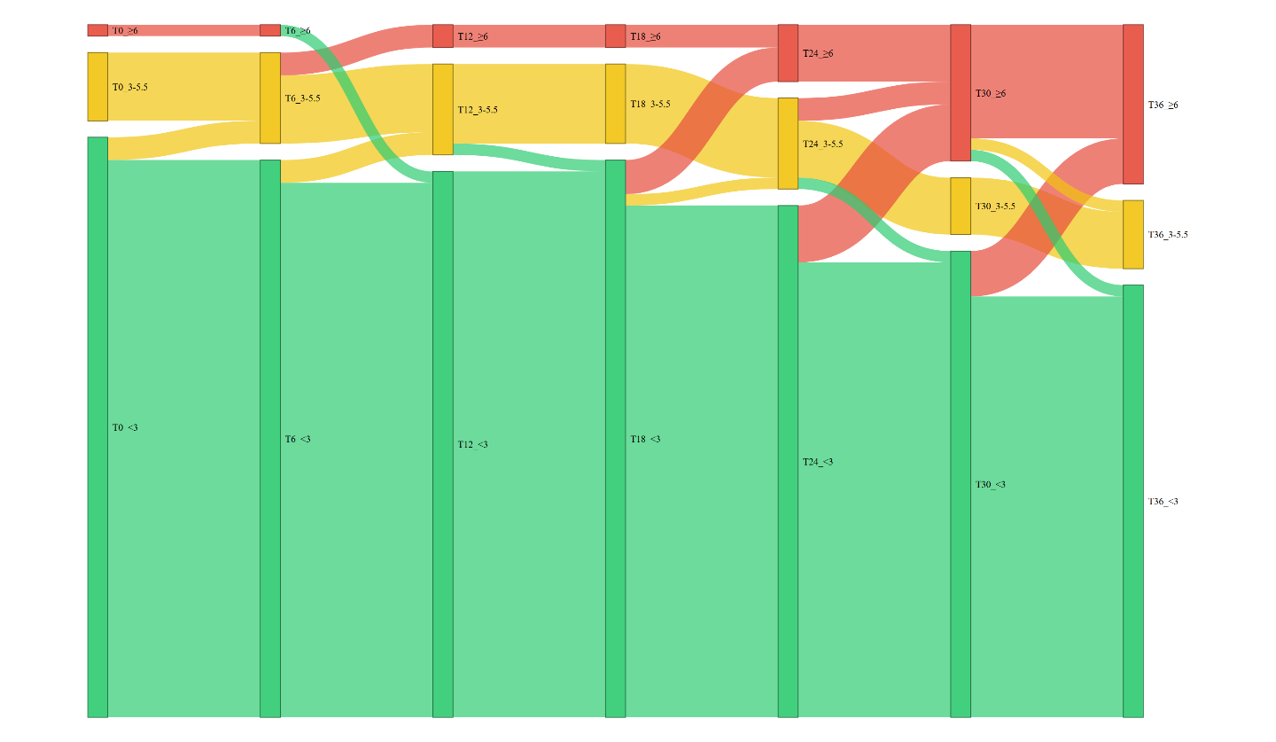
Figure 15 | Disability trend over the follow-up for all pwMS: Sankey plot.

From the graph illustrating the EDSS progression of the entire cohort, it is evident that, overall, most patients fall within the green range, corresponding to a low EDSS score (EDSS < 3), with thick and continuous flows throughout the follow‑up period. A smaller proportion of patients is positioned within the 3–5.5 range (yellow), with some transitions toward either the green or red categories. Patients with EDSS ≥ 6 (red) are few and tend to maintain high levels of disability over time, showing minimal improvement.
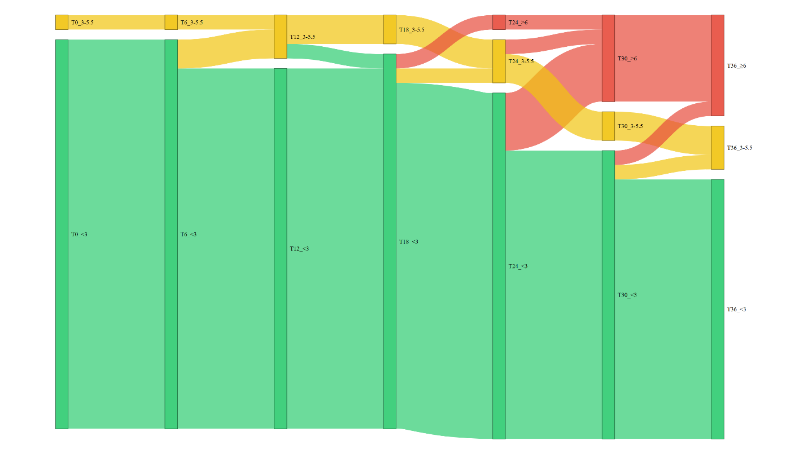
Figure 16 | Disability trend over the follow-up for pwMS TEC-treated: Sankey plot.

Most TEC-treated patients remain within the green range (<3) throughout the entire follow-up period. The flows are stable and continuous, with very few transitions toward the yellow (3–5.5) or red (≥6) ranges. This pattern indicates a generally low and stable level of disability, with minimal variation over time. Indeed, transitions toward higher EDSS scores are rare and do not represent the predominant trend.
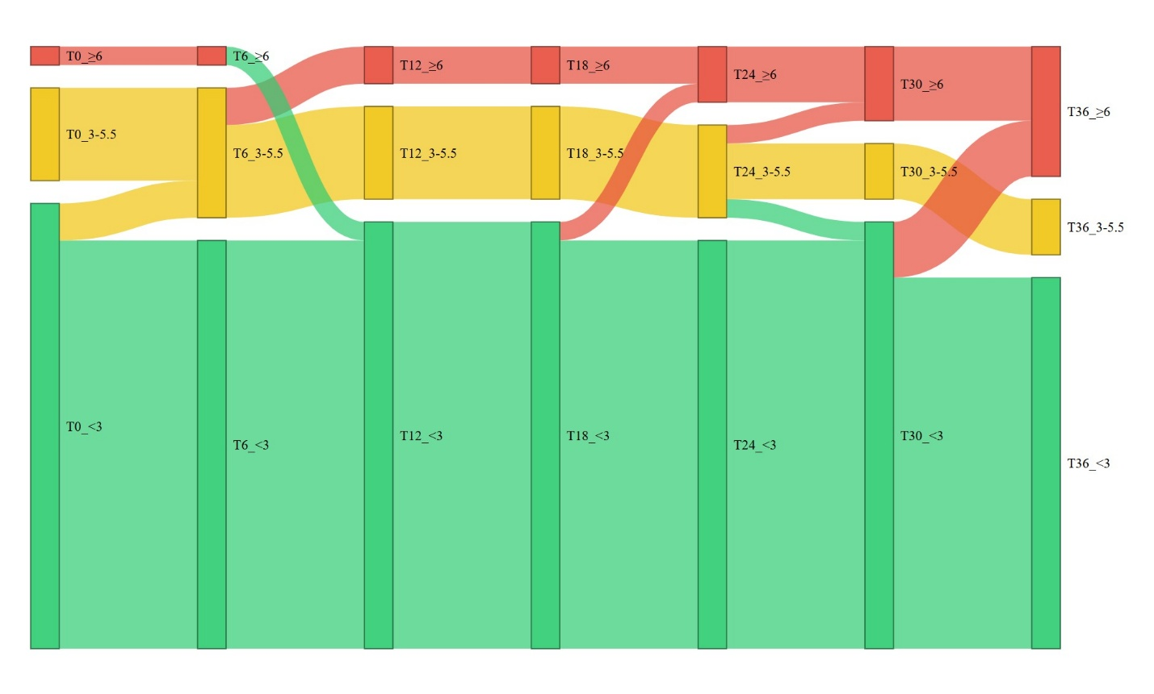
Figure 17 | Disability trend over the follow-up for pwMS MAV-treated: Sankey plot.

In the MAV‑treated group, by contrast, a greater degree of variability is observed: several individuals transition from the green category to the yellow or even the red category. Yellow and red flows are more prominent, particularly after T18–T24, indicating episodes of worsening or fluctuations in disability. Although the green category remains predominant, the number of transitions is higher compared with TEC patients. This pattern suggests a more dynamic clinical course, with individuals experiencing both improvements and deteriorations over time.
In summary, the MAV group shows higher mean EDSS values with greater stability over time, suggesting a more consistent level of disability. Conversely, the TEC group exhibits lower mean EDSS scores but greater individual variability, indicating a less uniform clinical course.
Subsequently, we calculated the incidence of at least one episode of clinical worsening.
We defined worsening as the occurrence of at least one of the following events:
- an increase of 0.5 points in the EDSS score
- the appearance of new lesions
- clinical relapses
We observed that neither therapy completely eliminates the risk of negative events during follow‑up, which is fully consistent with clinical practice. Indeed, both treatments are non‑curative and aim to reduce the likelihood of disease progression, although multiple sclerosis remains a condition for which no definitive cure is currently available.
To compare the effectiveness of the two treatments in maintaining the NEDA‑3 status, a survival analysis using Kaplan–Meier curves was performed. In the overall cohort, the curves for the MAV and TEC groups show an overlapping trend over time, with a gradual reduction in the proportion of patients free from disease activity. The log‑rank test (p = 0.87) does not reveal statistically significant differences between the two treatments, suggesting comparable effectiveness in maintaining NEDA‑3 status throughout the follow‑up.
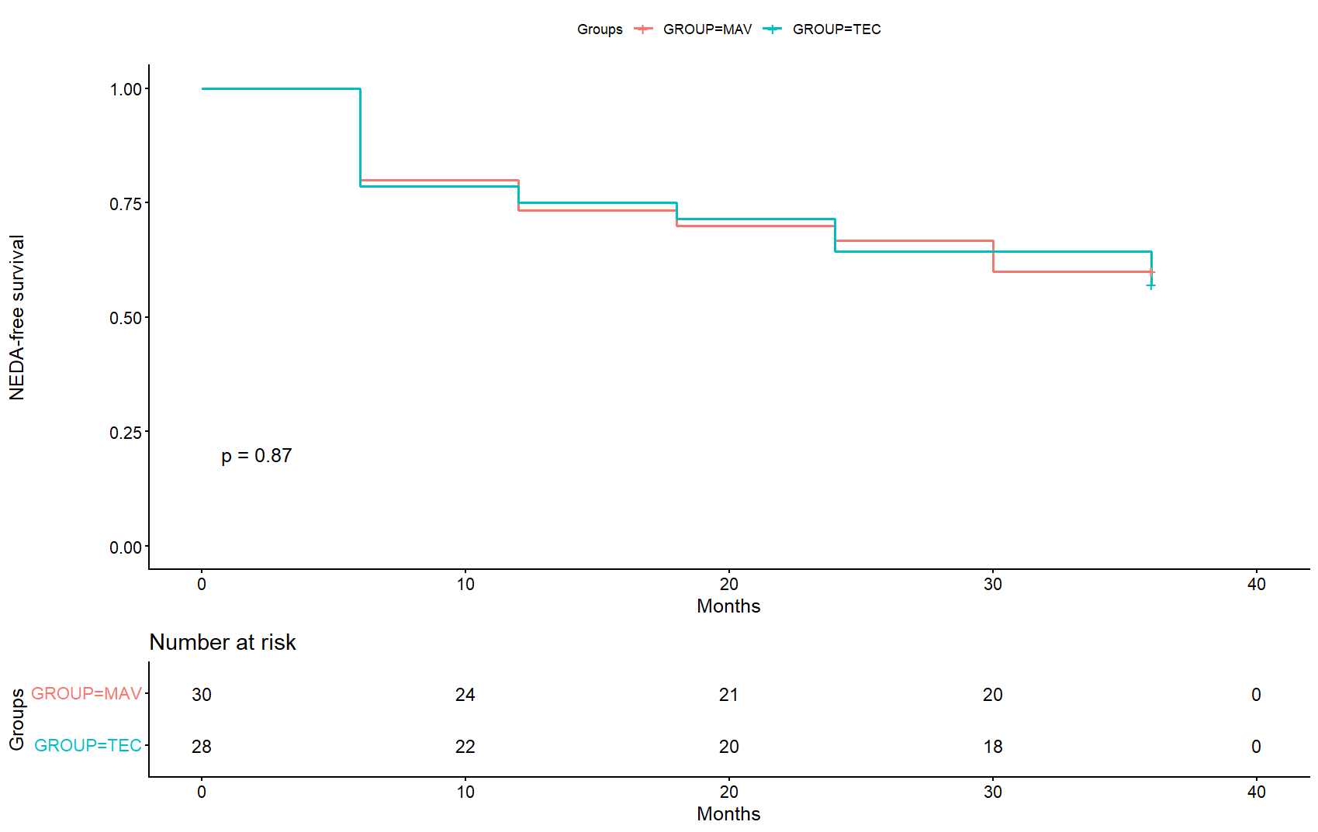
Figure 18 | NEDA-3-free survival analysis for all pwMS stratified for therapy

To further investigate the behavior of naïve patients, a second survival analysis restricted to this subgroup was performed. In this analysis as well, the Kaplan–Meier curves for the MAV and TEC groups appear overlapping, confirming the absence of significant differences between the two treatments in the time to loss of NEDA‑3 status.
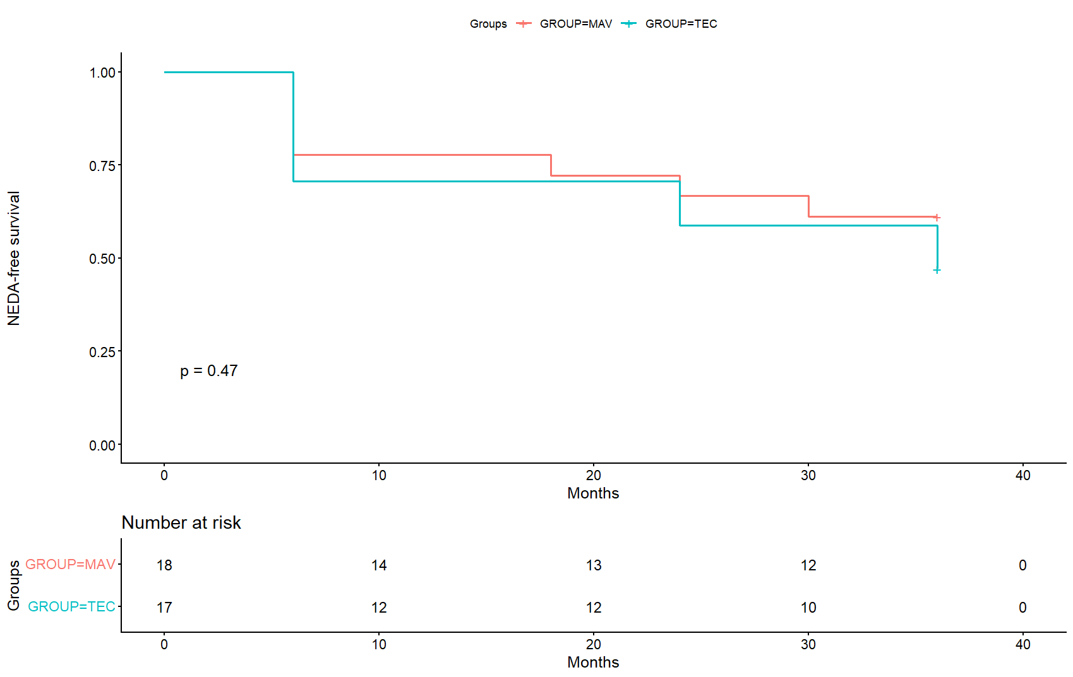
Figure 19 | NEDA-3-free survival analysis for naïve pwMS stratified for therapy

To assess whether there was a specific point during follow‑up at which the survival curves of the two treatments diverged markedly, we repeated the analysis by progressively setting different final timepoints: starting with T36 (as shown in the previous figures) and then sequentially evaluating each preceding timepoint. None of these analyses revealed a significant separation of the curves at any stage of the follow‑up.
The absence of a pronounced divergence across the follow-up suggests that MAV and TEC exhibit a comparable clinical profile in maintaining disease stability, both in the overall cohort and in the subgroup of naïve patients.
At this point, we performed several Cox regression analyses including both clinical and demographic variables, with the aim of identifying potential factors associated with the loss of NEDA‑3 status.
Given the relatively small sample size and the high number of variables to be considered, including all covariates within a single model led to unstable estimates and reduced statistical power. Therefore, to overcome this limitation, a more targeted strategy was subsequently applied, focusing the analyses on baseline clinical and MRI-related parameters considered most directly connected to disease progression.
It should also be specified that glucocorticoid exposure was assessed using two distinct methods: first, as a baseline variable (T0 corticosteroid treatment), and second, according to longitudinal exposure patterns, distinguishing patients treated only during follow-up, those receiving glucocorticoids both at baseline and during follow-up, and those who were never exposed.
Within the overall MAV-treated cohort, the analysis identified the presence of subtentorial lesions at baseline as the variable most strongly associated with subsequent NEDA-3 loss.
Kaplan–Meier curves demonstrated a lower probability of maintaining NEDA-3 status among patients with subtentorial lesions compared with those without them. The divergence between the two survival curves emerged early during follow-up and persisted throughout the entire period.
By the end of follow-up, approximately 74% of patients without subtentorial lesions maintained NEDA-3 status, whereas only about 42% of those with subtentorial lesions did so.
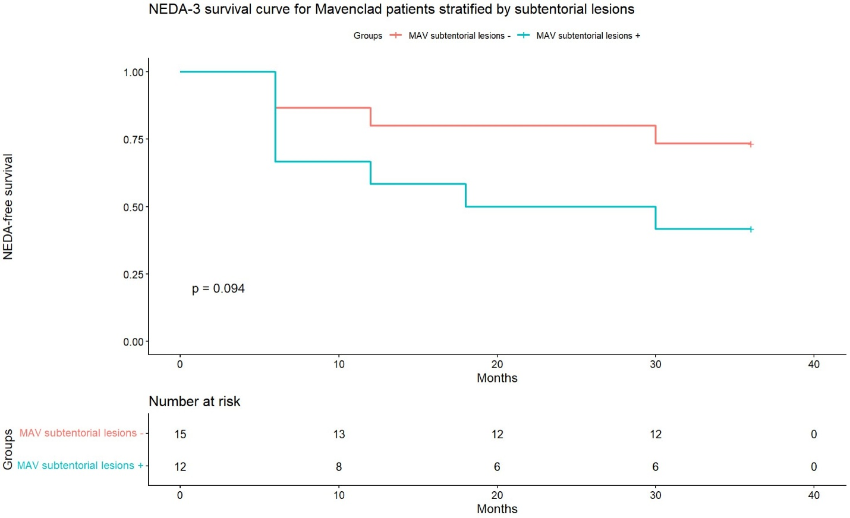
Figure 20 | NEDA-3-free survival analysis for pwMS MAV-treated. The graph is made following Cox analysis results.

3.2 Clinical and Demographic Profile of the TEC Cohort
First of all an exploratory data analysis (EDA) was performed to resume the main characteristics of the dataset, in addition to the analyses presented in the previous section describing the overall cohort.
The mean age at T0 was approximately 40.1 years (SD = 12.6), with values ranging from 19 to 58 years. Similarly, the mean age at diagnosis was 37.6 years (SD = 12.5), with a broader range (19–63 years) and two missing values, reflecting some heterogeneity within the study cohort.
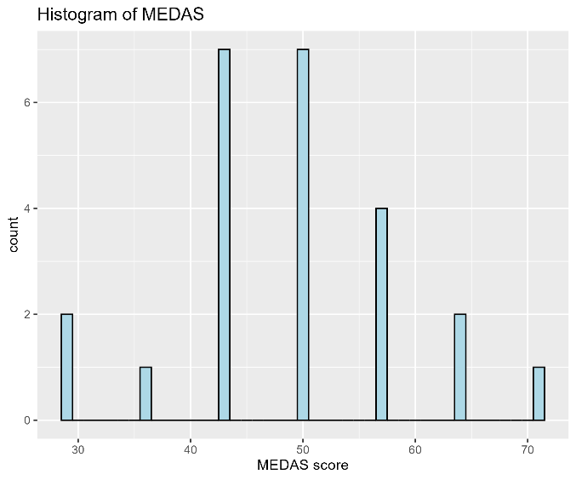
Figure 21 | Distribution of MEDAS within the TEC cohort
Both variables were evaluated for normality using the Shapiro–Wilk test. Age at T0 did not follow a normal distribution (p = 0.03), whereas age at diagnosis showed no significant deviation from normality (p = 0.10). This difference between age at diagnosis and age at baseline indicates that, on average, patients initiated therapy relatively soon after receiving their diagnosis.
The MEDAS score showed a mean value of 48.8 (SD = 10.4), with values ranging from 28.6 to 71.0 and four missing observations. These results indicate a moderate adherence to the Mediterranean diet within the cohort. The distribution appeared approximately normal, as confirmed by both graphical evaluation and the Shapiro–Wilk test (p = 0.26).
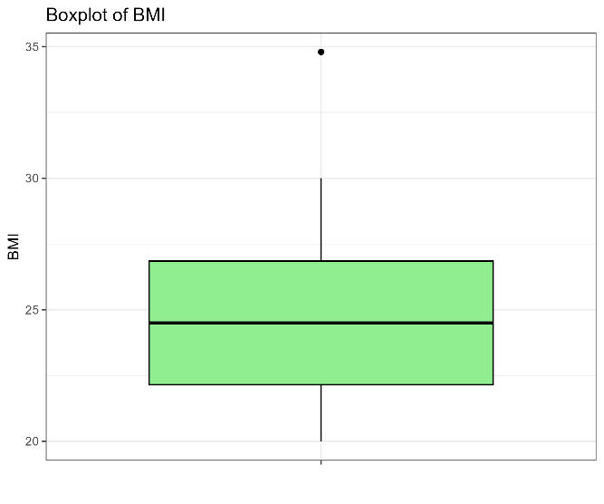
Figure 22 | Distribution of BMI within the TEC cohort
The BMI distribution showed a mean value of 24.99 (SD = 3.57), with a median of 24.5 and a range spanning from 20.0 to 34.8, confirming the presence of individuals in both underweight and overweight categories. The Shapiro–Wilk test confirmed that the BMI distribution was approximately normal (p = 0.21).
The boxplot illustrates the distribution of BMI values within the study population. A single data point above 34 denotes an outlier. Overall, the distribution appears symmetric, with most participants exhibiting BMI values within the normal to slightly elevated range.
The EDSS scores at different time points (T0–T36) showed mean values ranging between approximately 1.0 and 1.4, indicating relatively low levels of disability within the study cohort.
Overall, the distribution of EDSS values appeared non-normal and slightly skewed, which is consistent with the clinical nature of the variable as confirmed by the Shapiro–Wilk test (p < 0.05 for EDSS at each timepoint).
These findings suggest that non-parametric methods may be more appropriate for the analysis of EDSS, as it is non-normally distributed. Furthermore, the presence of relatively limited variability across different time points highlights the importance of further longitudinal analysis to assess the progression of the disease.
Finally, it is important to highlight that missing data were present at several time points, which could affect the robustness of the analysis and should be taken into account in next steps.
Relatively low EDSS scores are consistent with a population affected by RRMS under treatment.
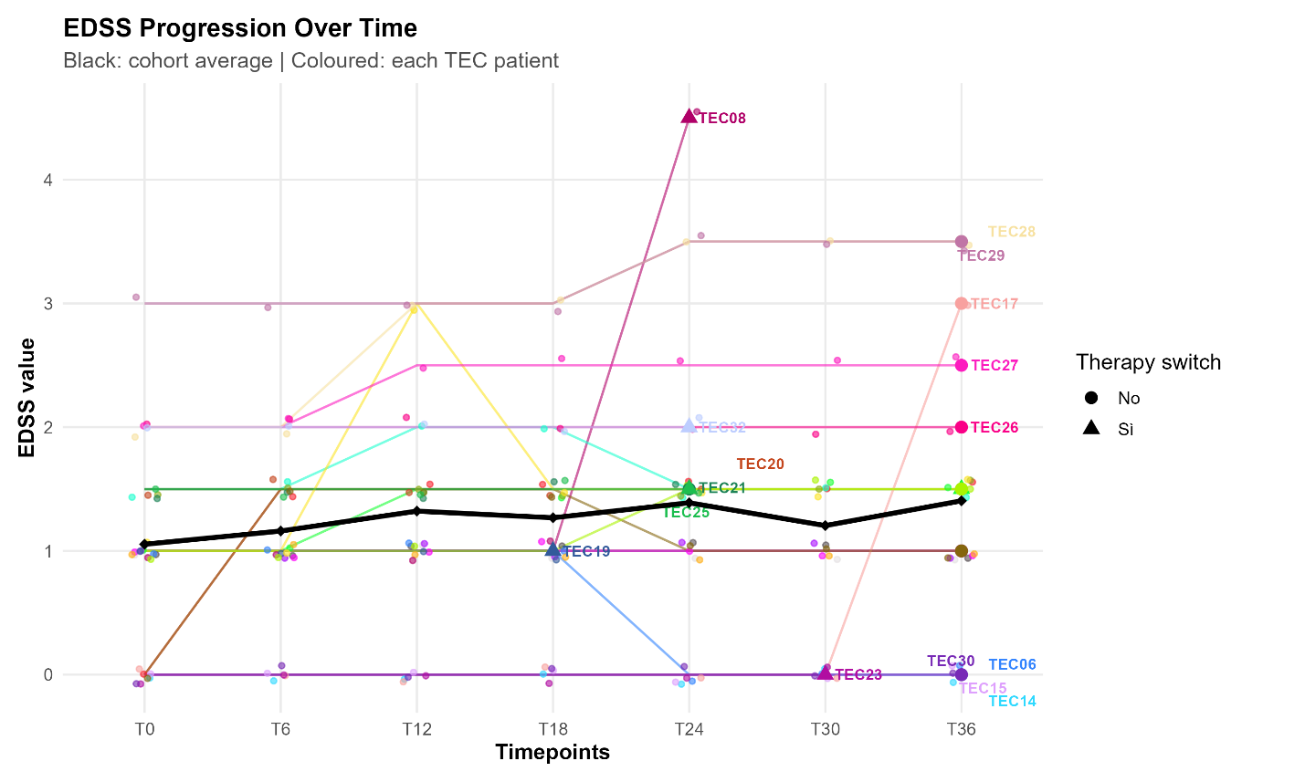
Figure 23 | EDSS Progression Over Time for pwMS TEC-treated. The plot displays individual trajectories through colored lines, one for each patient. In addition to them, the cohort mean is shown as a thicker black line with black points at the corresponding timepoints.
The combination of individual lines, highlighted final points, and the cohort average allows for an immediate visualization of both the overall trend in disability within the group and the intra-patient variations, revealing patterns of improvement, stability, or worsening throughout the follow-up period.

About lifestyle factors, regarding smoking habits the majority of patients were non-smokers (86.96%), while levels of physical activity indicated that most patients were partially active (40.91%).
Regarding clinical features, variables such as lesion burden and clinical presentation showed the heterogeneity in disease manifestation among patients. In particular, lesion burden was relatively balanced, with 45.5% of positive patients and 54.5% showing less than 10 lesions at T0, indicating variability in disease severity into the population.
Also clinical presentation was heterogeneous, with the most frequent manifestation of sensory symptoms (36.36%), followed by brainstem involvement and optic neuritis (both 27.27%), suggesting a different clinical onset of disease.
Also these findings highlight the heterogeneous nature of multiple sclerosis at onset.
Treatment-related variables proved that some patients had received antibiotic therapy (11.54%) and 50% of patients with available data had experienced glucocorticoid treatment, reflecting common therapeutic strategies in the treatment of MS. Furthermore, 26.9% of patients switched therapy, providing treatment adaptation over time.
For a better characterization of disease activity, imaging-related variables, such as spinal lesions, subtentorial lesions and gadolinium-enhancing lesions were analyzed.
Their presence suggests variability in disease severity and progression in this subset of patients.
The majority of patients are classified as treatment-naïve at baseline (60.71%), highlighting that most cases within the cohort were newly treated individuals.
Additionally, the sex' distribution (36% male, 64% female) reflects the already known epidemiological predominance of women with multiple sclerosis (Lublin et al., 2022).
The proportion of patients attaining full recovery (50%) provides a preliminary descriptive indication of clinical outcomes within the study cohort, suggesting variability in treatment response.
In general, these results highlight the clinical and demographic heterogeneity of the study population, supporting the need for stratified and longitudinal analyses.

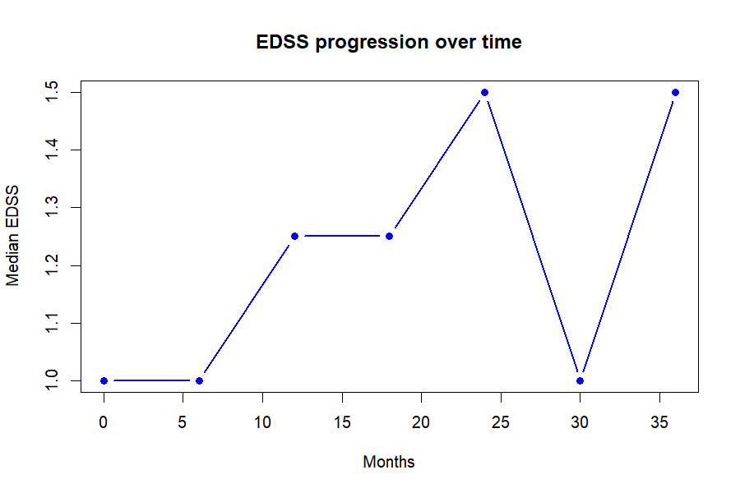
Figure 24 | EDSS Progression for Longitudinal Descriptive Analysis
3.2.1 Longitudinal Analysis
A longitudinal descriptive analysis was performed to evaluate disease progression during time. Despite some fluctuations, the median EDSS remained low throughout the follow‑up period. After initial stability between T0 and T6, a gradual increase was observed up to T24, reaching a median of 1.5. This was followed by a temporary reduction to baseline levels at T30, and a subsequent rise again to 1.5 at T36.
Overall, these results confirm that the study population maintained a low level of disability during treatment, with only minor variations over time. The number of patients available at each time point decreased in later visits, reflecting the presence of missing data that should be considered in the analysis.
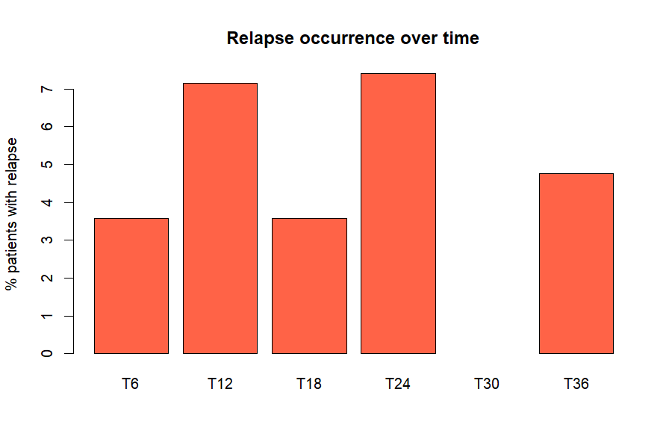
Figure 25 | Relapse Occurrence Over Time. The barplot illustrates the proportion of patients experiencing relapses at each follow-up timepoint.
These findings emphasize that, on one hand there's a general stability at the group level, on the other individual patient trajectories may differ substantially over time.
The proportion of patients experiencing relapses at each follow-up time point was analyzed.
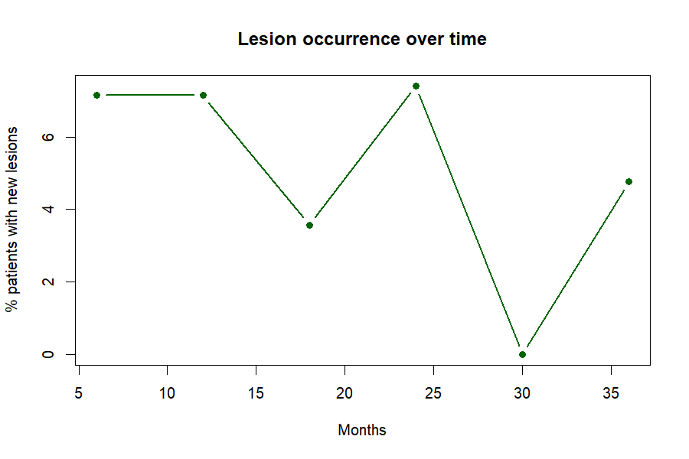
Figure 25 | Lesion Occurrence Over Time. The lineplot show percentages of pwMS TEC-treated developing new lesions over time.

The occurrence of relapses fluctuated over time, with moderate rates at T6 (approximately 4%) and T18 (4%), and two clear peaks at T12 and T24 (around 7%). No relapses were recorded at T30, while a slight increase was observed at T36 (approximately 5%). Overall, these results indicate variable disease activity across follow‑up visits, without evidence of a consistent upward or downward trend in relapse occurrence.
The same analysis was done to show the proportion of pwMS TEC-treated developing new lesions over time, providing an additional measure of disease activity.
In general, the percentage of patients with new lesions remains relatively stable across most time points, with little fluctuations.
The percentage of patients with new lesions showed high values at T6 and T12 (around 7%), followed by a decrease at T18 (approximately 4%). A second peak was observed at T24, after which lesion occurrence dropped to 0% at T30. Subsequently, a slight increase was noted at T36 (around 5%). Overall, these results highlight variable radiological disease activity across follow‑up visits, consistent with the relapsing‑remitting nature of the disease and supporting the presence of intermittent activity within the study cohort.
The proportion of patients receiving corticosteroid treatment during follow-up remained low across all time points (n=4).
This pattern is consistent with the clinical use of corticosteroids in MS, where they are typically used on demand to manage acute relapses and associated symptoms, such as functional impairment or pain.
To better investigate longitudinal patterns, the dataset was reshaped from wide to long format. This modification permits a more flexible analysis of repeated measurements during follow-up and facilitates the use of advanced graphical and statistical methods.
In the long format dataset, each row corresponds to a single measurement at a specific time point for each patient, to have a more detailed representation of temporal trends in EDSS scores, relapses, lesion occurrence, and corticosteroid use.
These analyses are consistent with the previous ones for EDSS, occurrence of relapses and new lesions during the follow-up.
To formally assess if disability changed over time, a Friedman test was performed on repeated EDSS values: just a subset of patients with complete EDSS measurements across time points (T0, T6, T12, T24) were considered, in order to ensure comparability of repeated observations.
As a result, the sample size was reduced compared to the full dataset, which should be considered when interpreting the findings.
The Friedman test revealed a statistically significant difference in EDSS scores across time points (p = 0.005), indicating that disability levels varied significantly during follow‑up.
This finding contrasts with the previous descriptive analysis, which suggested only minor fluctuations without a clear trend.
In conclusion, the observed changes in EDSS scores over time reflect a meaningful variation in clinical status, rather than random noise, suggesting that some patients experienced non‑stable disability trajectories throughout the study period.
To assess if the frequency of relapse changed over time, a Cochran’s Q test was performed on repeated binary relapse data.
The results did not show a significant difference in relapse frequency across time points (p = 0.82), suggesting that the portion of patients experiencing relapses remained overall stable during the follow-up period.
This finding is consistent with the descriptive analysis: there were fluctuations in relapse occurrence without a clear decreasing or increasing trend over time.
This means that the variability in relapse rates is attributable to random variation rather than a systematic change in disease activity.
Also the Cochran’s Q test for radiological activity did not reveal a statistically significant difference in the proportion of patients with new lesions across time points (p = 0.78).
This indicates that the radiological activity remained stable throughout the follow‑up, with no consistent trend toward increased or decreased lesion occurrence.
To explore potential associations between continuous variables and disability scores, Spearman correlation analyses were performed.
No significant correlations were observed between EDSS and MEDAS score, BMI and age at T0 (all p>0.05). These results indicate the absence of important association between these variables and EDSS levels.

3.3 Analysis of TEC Patients: Association Between Metadata and Gut Microbiota
After describing the metadata, this section examines the analyses performed on pwMS TEC-treated, with the aim of exploring the association between demographic and clinical variables and the gut microbiota composition, and of assessing how these microbial profiles evolve over time. The study includes three main time points: T0, corresponding to the baseline before treatment initiation; T1, one month after the beginning of the therapy; and T12, representing the 12‑month follow‑up.
All analyses were carried out using the PurrBiom application, as detailed in the Materials and Methods chapter, in order to evaluate within‑sample microbial diversity (alpha diversity), differences between samples (beta diversity), and the overall taxonomic composition through stacked‑bar plots. The aim is to characterize temporal microbial variability and to identify potential correlations with the clinical and demographic parameters of the cohort.
For this reason, only statistically significant analyses will be presented; however, all variables in the dataset were examined.

3.3.1 Significant Alpha‑Diversity in Eukaryotic Communities at T0
Antibiotic intake prior to the initiation of the therapy was statistically significant (p = 0.028) in pwMS TEC-treated, suggesting greater eukaryotic diversity at T0. This indicates that the composition of eukaryotic communities was more heterogeneous in subjects who had received antibiotics, reflecting a re‑organization of the gut microbiota.
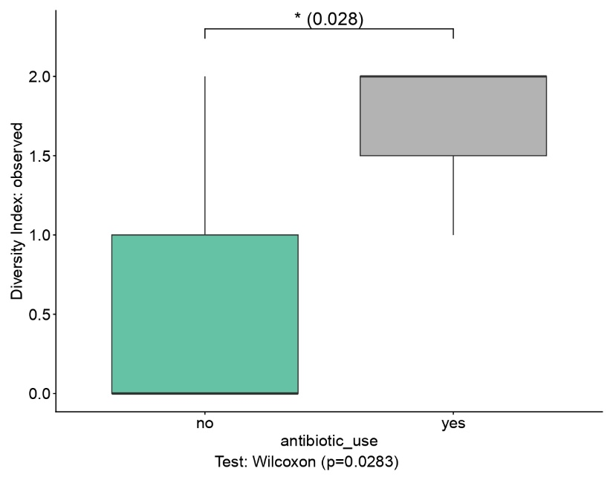
Figure 26 | Alpha Diversity for Antibiotic Intake prior TEC-treatment initiation. The figure shows a statistically significant increase in eukariotic diversity at T0 using Observed Index.

3.3.2 Significant Alpha‑Diversity in Bacterial Communities During Follow‑Up
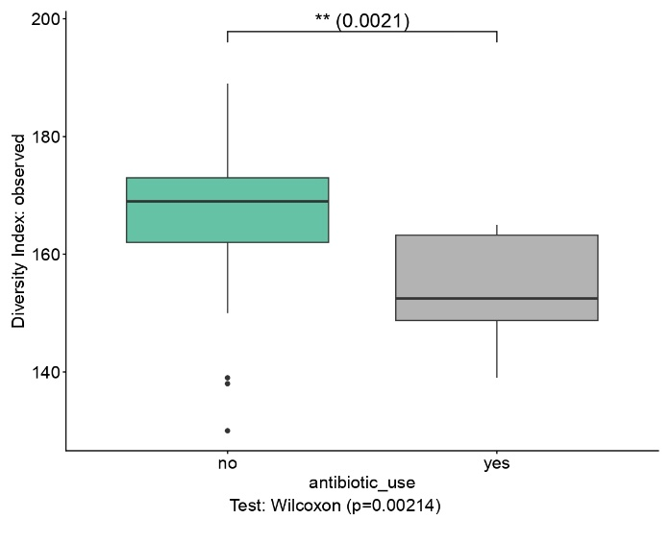
Figure 27 | Antibiotic Intake Alpha Diversity during the follow-up. The figure shows a statistically significant decrease in bacterial diversity in one-year follow-up using Observed Index.
The use of antibiotics prior to the initiation of therapy was also statistically significant during follow‑up (p = 0.0021), although in this case it indicates a reduction in bacterial diversity. When compared with the analysis performed at T0, where antibiotic intake was significantly associated with an increase in eukaryotic diversity, this pattern suggests that the effect of antibiotics is not stable over time. Initially, antibiotic exposure may promote greater heterogeneity within eukaryotic communities, but in the long term it tends to reduce bacterial microbial complexity, probably due to less balanced recolonization or incomplete recovery of the gut flora.

The BMI during follow‑up was statistically significant (p = 0.002). This result suggests that BMI is associated with the composition of the bacterial microbiota over time: subjects with a normal BMI (BMI < 25) exhibited a more heterogeneous microbial community, whereas overweight subjects showed reduced diversity. Such a difference may reflect metabolic or inflammatory alterations influencing the structure of the microbiota throughout the follow‑up period.
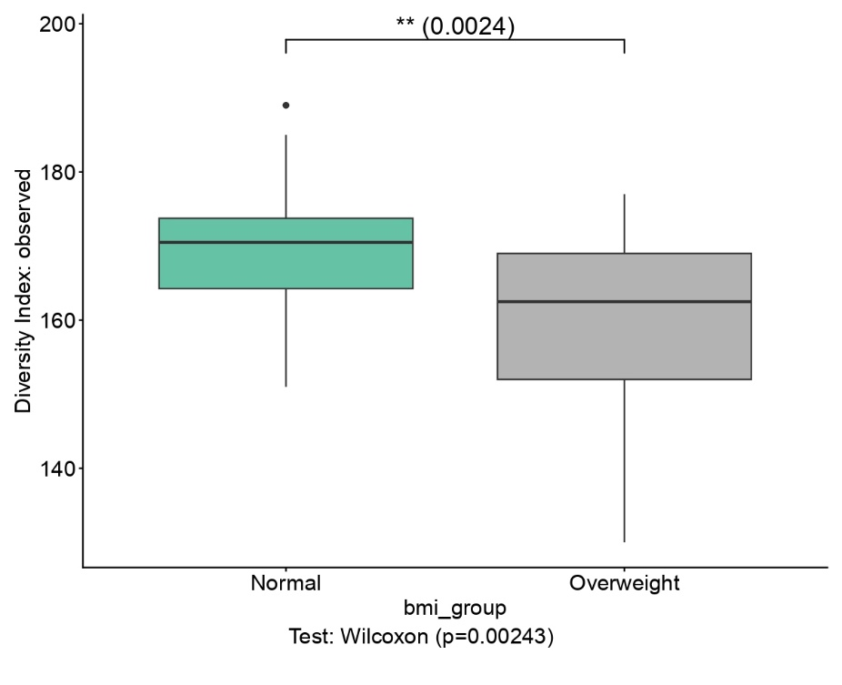
Figure 28 | BMI during follow-up Alpha Diversity. The figure shows a statistically significant decrease in bacterial diversity in overweight pwMS in one-year follow-up using Observed Index

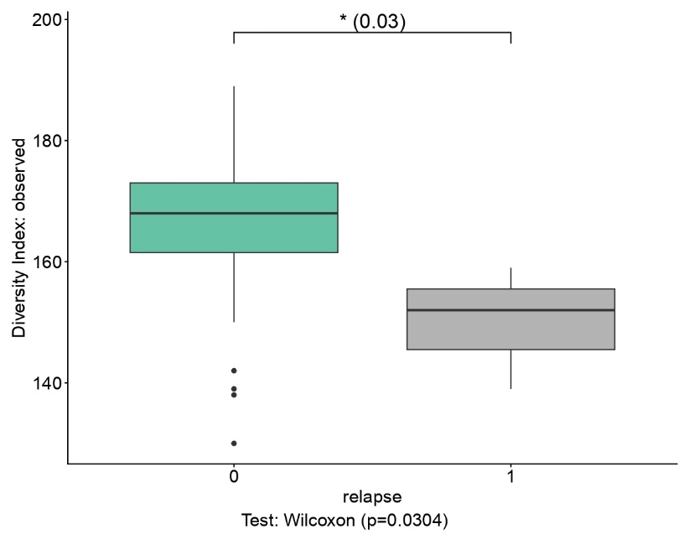
Figure 29 | Relapse-events during the follow-up Alpha Diversity. There is a reduction of microbial diversity in pwMS TEC-treated that presented relapses compared to patients without relapses during one-year follow-up.

The analysis concerning the presence of relapses during follow‑up was also statistically significant (p = 0.03). This result suggests that lower microbial diversity is associated with the occurrence of relapses during follow‑up, reflecting a condition of dysbiosis or instability that may render these subjects more susceptible to clinical relapses.

3.3.3 Significant Beta‑Diversity in Bacterial Communities
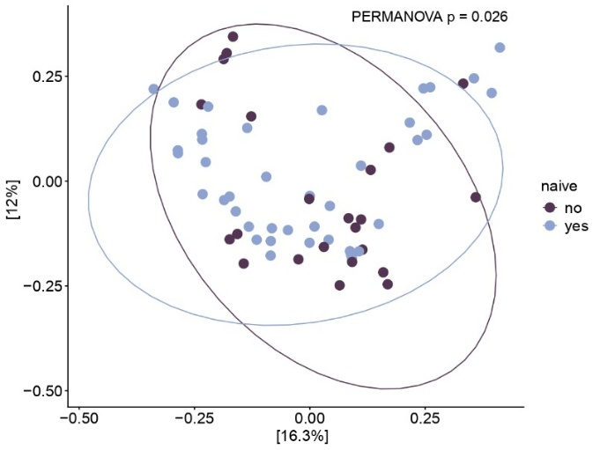
Figure 30 | Naïve status Beta Diversity

The beta‑diversity analysis associated with the patients’ naïve status was statistically significant (p = 0.02). Non‑naïve subjects exhibited a microbial composition distinct from that of naïve patients, likely due to direct or indirect effects of previous therapy on the gut microbiota.

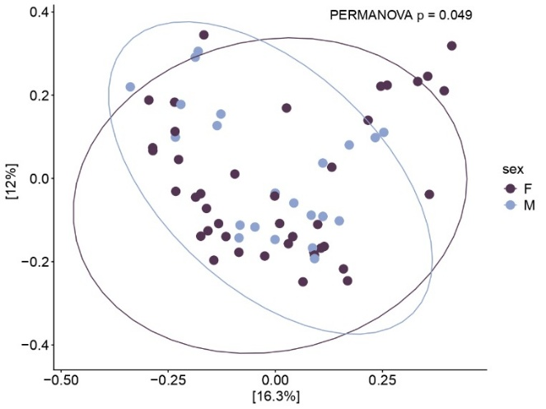
Figure 31 | Sex Beta Diversity
The beta‑diversity analysis related to the patients’ sex was also statistically significant (p = 0.04). This indicates that sex shapes the structure of the intestinal microbiota, maybe linked to hormonal, metabolic, or immune differences that influence bacterial composition. In particular, women (F) show a more homogeneous microbial profile, whereas men (M) exhibit a more heterogeneous bacterial community.

3.3.4 Taxonomic profile of the bacterial and eukaryotic microbiota: Stacked bar plots
As an initial analysis, I visualized the differences in intestinal bacterial species by stratifying the samples according to sex.
In women (F), a higher abundance of Bacteroides uniformis and Phocaeicola dorei was observed: they are species belonging to the phylum Bacteroidota and associated with metabolic and immunomodulatory functions. A notable presence of Faecalibacterium prausnitzii was also detected, a bacterium known for its anti‑inflammatory properties and butyrate production. Overall, the female profile appears more diverse and balanced, with a more heterogeneous distribution across taxa.
In men (M), a greater representation of Blautia wexlerae was observed, a butyrate‑producing species often associated with metabolic profiles distinct from those of Faecalibacterium. Consequently, the male profile appears more concentrated around specific genera, with a less balanced overall composition.
These differences, consistent with the significant beta‑diversity (PERMANOVA p = 0.049), suggest that sex modulates the structure of the intestinal microbiota.
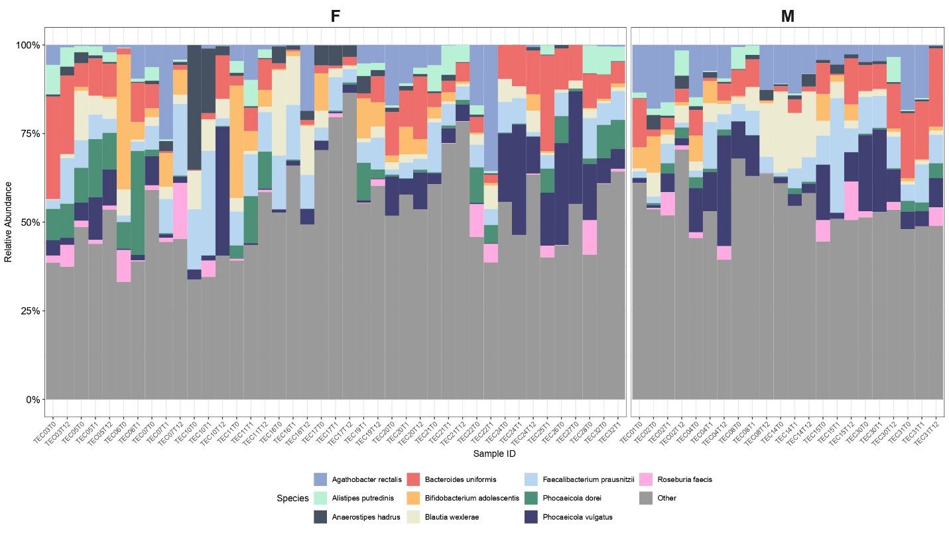
Figure 32 | Stacked Bar Plot stratified by Sex

The analysis of eukaryotic genera also revealed interesting patterns showing that the intestinal microbiota in females is more heterogeneous (with the presence of Pichia, Candida, Debaryomyces, and Malassezia), whereas in males it tends to be dominated by a single genus. In both sexes, Saccharomyces is the predominant taxon.
The analysis of relapse status revealed clear differences in gut microbial composition.
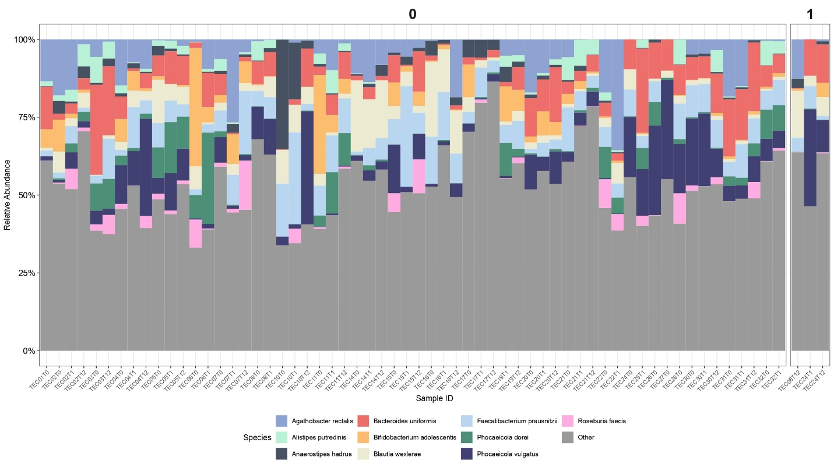
Figure 33 | Stacked Bar Plot stratified by Relapse Occurrence

Patients without relapses (0) showed a more balanced community, with heterogeneous distributions of Faecalibacterium prausnitzii, Agathobacter rectalis, Roseburia faecis, and Bifidobacterium adolescentis. In contrast, patients with at least one relapse during the follow-up (1) displayed reduced diversity and a stronger predominance of Bacteroides and Phocaeicola, indicating a simplified microbial structure. It is also evident that only a small subset of patients experienced relapses compared with the majority who remained relapse‑free. In the small subset of patients who experienced at least one relapse, Roseburia faecis appears almost absent, showing a markedly reduced abundance compared with the relapse‑free group.
This pattern is consistent with the alpha diversity analysis (Wilcoxon p = 0.03), which confirms a significantly higher observed diversity in patients without relapses compared to those who experienced at least one relapse.
The analysis performed on eukaryotic communities again shows the predominance of Saccharomyces in both groups.
At this stage, I stratified the patients based on their naïve status before starting Tecfidera therapy.
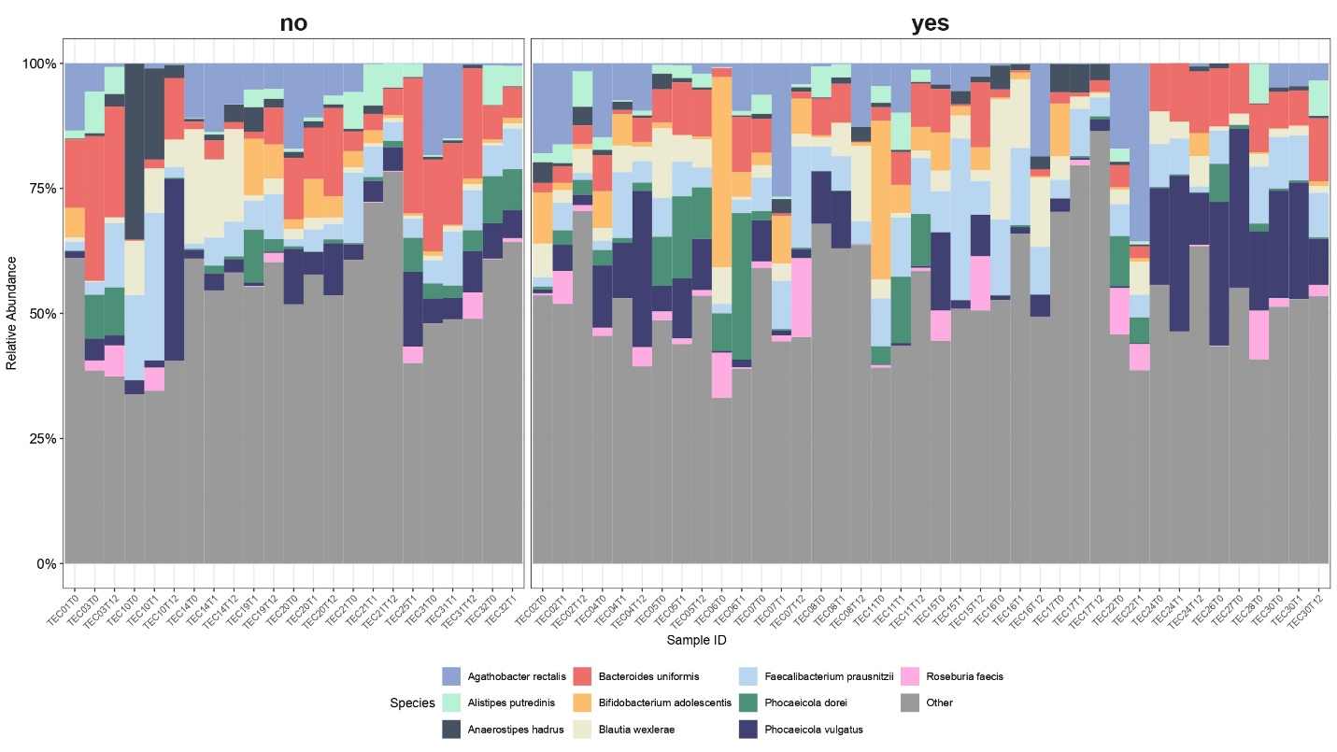
Figure 33 | Stacked Bar Plot stratified by Naïve Status

The analysis shows an overall similar microbial composition between the two groups, with Bacteroides uniformis and Faecalibacterium prausnitzii well distributed in both previously treated and naïve patients. However, some differences are evident: a greater number of naïve samples display Bifidobacterium adolescentis, while Phocaeicola vulgatus, although present in both groups, appears more represented in naïve patients. Agathobacter rectalis shows a homogeneous distribution, whereas Roseburia faecis is overall more abundant in the naïve group. Taken together, these findings suggest that prior therapeutic exposure does not substantially affect the dominant taxa, but may modulate the relative abundance of specific species that are relevant from a metabolic and inflammatory perspective.
Even with this stratification, the predominant eukaryotic genus remains Saccharomyces.
In the next graph, the analysis of gut bacterial species is shown by stratifying patients according to their BMI (normal or overweight).
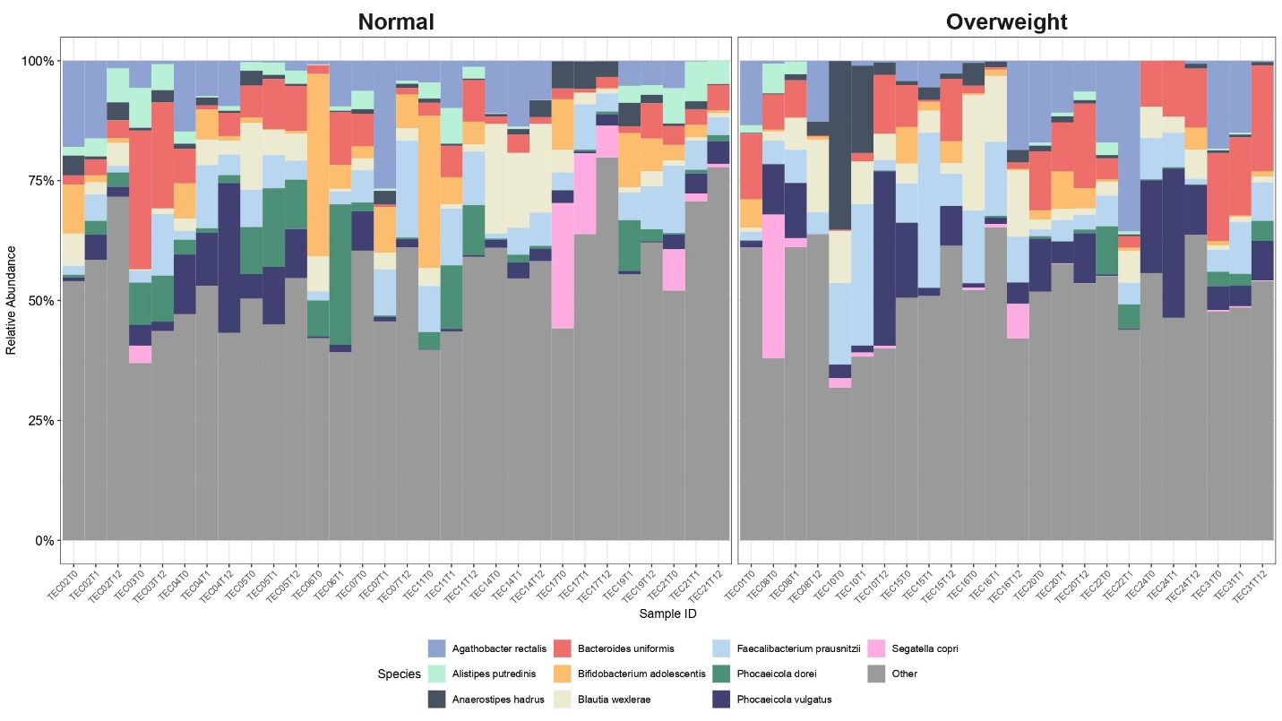
Figure 34 | Stacked Bar Plot stratified by BMI (overweight means BMI>25)

Bacteroides uniformis is present in both groups, representing one of the dominant taxa regardless of body weight status. Bifidobacterium adolescentis is more abundant in subjects with normal BMI, suggesting a microbial profile richer in beneficial species associated with balanced metabolic functions. Conversely, Anaerostipes hadrus and Phocaeicola vulgatus are more prevalent in the overweight group, indicating a possible association with metabolic or inflammatory alterations. Phocaeicola dorei is more represented in normal-weight subjects, while Segatella copri appears scarcely represented in both groups. Overall, the graph suggests that BMI influences the structure of the gut microbiota, showing a tendency toward lower diversity and greater predominance of species associated with altered metabolic profiles in overweight individuals.
Again, within the eukaryotic communities, the most abundant genus is Saccharomyces.
At this stage, I stratified the patients according to their MEDAS score: those with a value above the median (50.0) were assigned to the high group, whereas those with a lower score were classified as the low group.
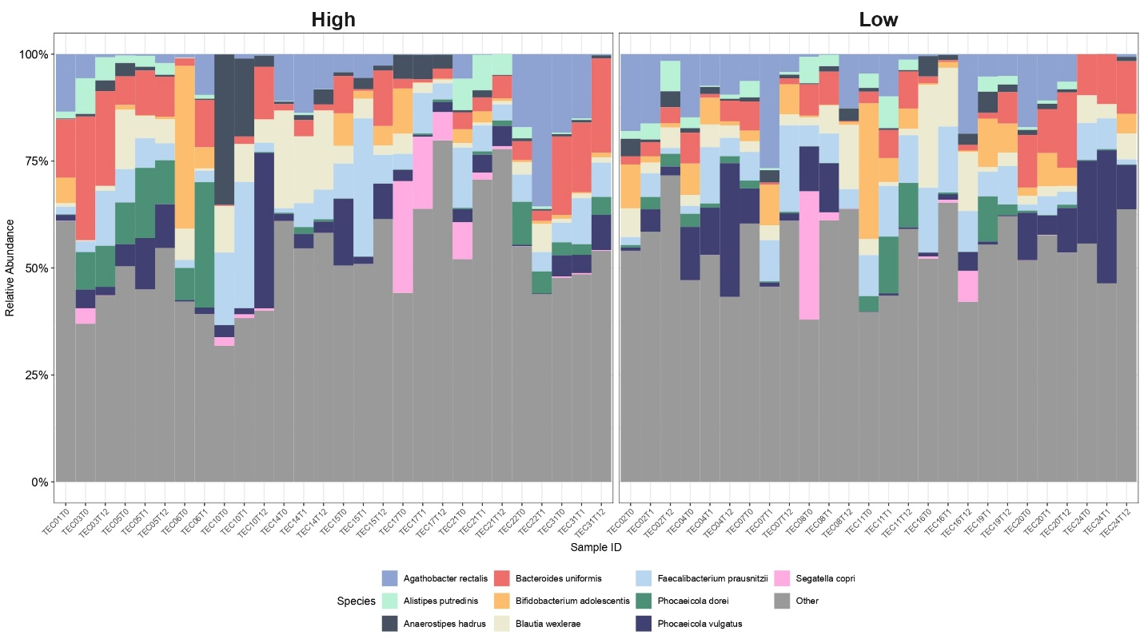
Figure 35 | Stacked Bar Plot stratified by MEDAS score

Bacteroides uniformis is more abundant in the high‑score group, whereas Agathobacter rectalis and Bifidobacterium adolescentis show a similar distribution across both groups. Phocaeicola dorei is more represented among subjects with higher scores, while Blautia wexlerae is found in all samples of the low group and in fewer samples of the high group. Finally, Phocaeicola vulgatus appears more represented in subjects with lower scores. Overall, these results suggest that adherence to the Mediterranean diet may influence gut microbiota composition, promoting a greater presence of potentially beneficial species in individuals with higher MEDAS scores.
Once again, even with this stratification, the most abundant eukaryotic genus in both groups is Saccharomyces.

3.4 MaAsLin3 analysis
3.4.1 MaAsLin3 analysis: Eukaryotes
In this analysis, I again report only statistically significant results, specifically for abundance, as no bacterial or eukaryotic taxa were found to be significant for prevalence. Based on the outcomes obtained with PurrBiom, I first examined Saccharomyces, and in particular Saccharomyces cerevisiae.
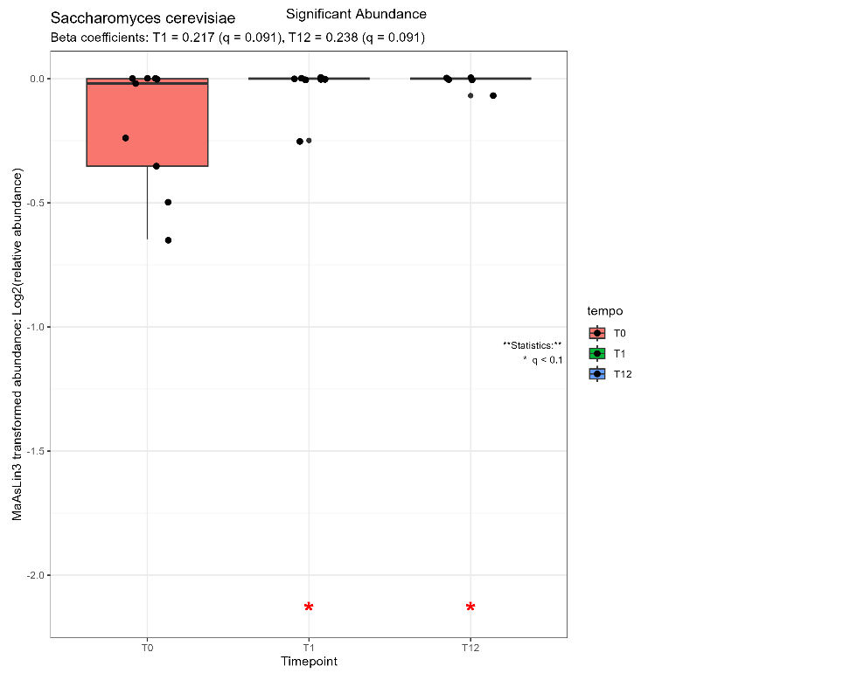
Figure 36 | Saccharomyces cerevisiae Relative Abundance during the follow-up

The graph illustrates the variation in the relative abundance of Saccharomyces cerevisiae across the three timepoints considered, calculated using MaAsLin3. The species is statistically significant (q < 0.1) in the comparisons between T0 and the subsequent timepoints, as indicated by the red asterisks below the boxplots for T1 and T12. The beta coefficients (T1 = 0.217 and T12 = 0.238) indicate an increase in abundance over time, suggesting a positive trend following the initiation of treatment and the maintenance of this increase after one year. Overall, Saccharomyces cerevisiae represents the main eukaryotic species showing significant changes throughout the follow‑up, indicating a possible adaptive or metabolic response of the eukaryotic microbiota to the therapeutic intervention.

3.4.2 MaAsLin3 analysis: Bacteria
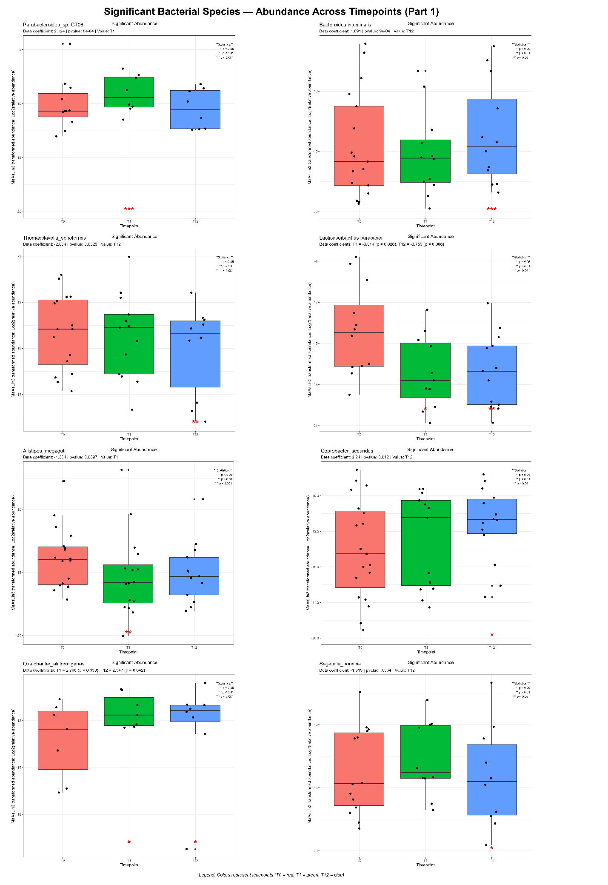
Figure 37 | Significant Bacteria Relative Abundance (part 1)

The longitudinal analysis conducted with MaAsLin3 highlighted fifteen bacterial species with statistically significant variations in abundance across the three timepoints (T0, T1, T12). The abundance values are expressed as log10 of the MaAsLin3 transformation, and the red asterisks indicate the resulting significance (* p < 0.05, ** p < 0.01, *** p < 0.001).

The species Parabacteroides sp. CT06 shows a significant increase in abundance at time T1 compared to T0 (β = 2.024, p = 0.0008). This increase suggests an initial positive response to the treatment or to a possible dietary change, with subsequent stabilization at T12.
For the species Bacteroides intestinalis, a significant increase in abundance is observed at T12 (β = 1.691, p = 0.0009), indicating an upward trend over time. The species therefore appears more represented in the long‑term follow‑up.
Thomasclavelia sporiformis shows a significant reduction in abundance at T12 (β = −2.064, p = 0.0029), suggesting a progressive decrease over the course of the year. This pattern may reflect an effect of the treatment or possible competition with other taxa.
Lactobacillus paracasei presents two significant results: an increase at T1 (β = −3.014, p = 0.026) and a reduction at T12 (β = −3.750, p = 0.006). This pattern indicates a progressive decline from the first month of therapy to the end of the year.
Regarding Alistipes megaguti, abundance decreases significantly at T1 (β = −1.364, p = 0.0097), suggesting an early reduction after the initiation of Tecfidera treatment.
Coprobacter secundus shows a significant increase at T12 (β = 2.24, p = 0.012), indicating late growth during the follow‑up. The species may be associated with processes of microbiota rebalancing over time.
Oxalobacter aliiformigenes presents significant increases both at T1 (β = 2.786, p = 0.039) and at T12 (β = 2.547, p = 0.042), with a constant upward trend.
Segatella hominis shows a significant reduction in abundance at T12 (β = −1.919, p = 0.034), indicating a decrease over the long term. This behavior may reflect a negative adaptation.
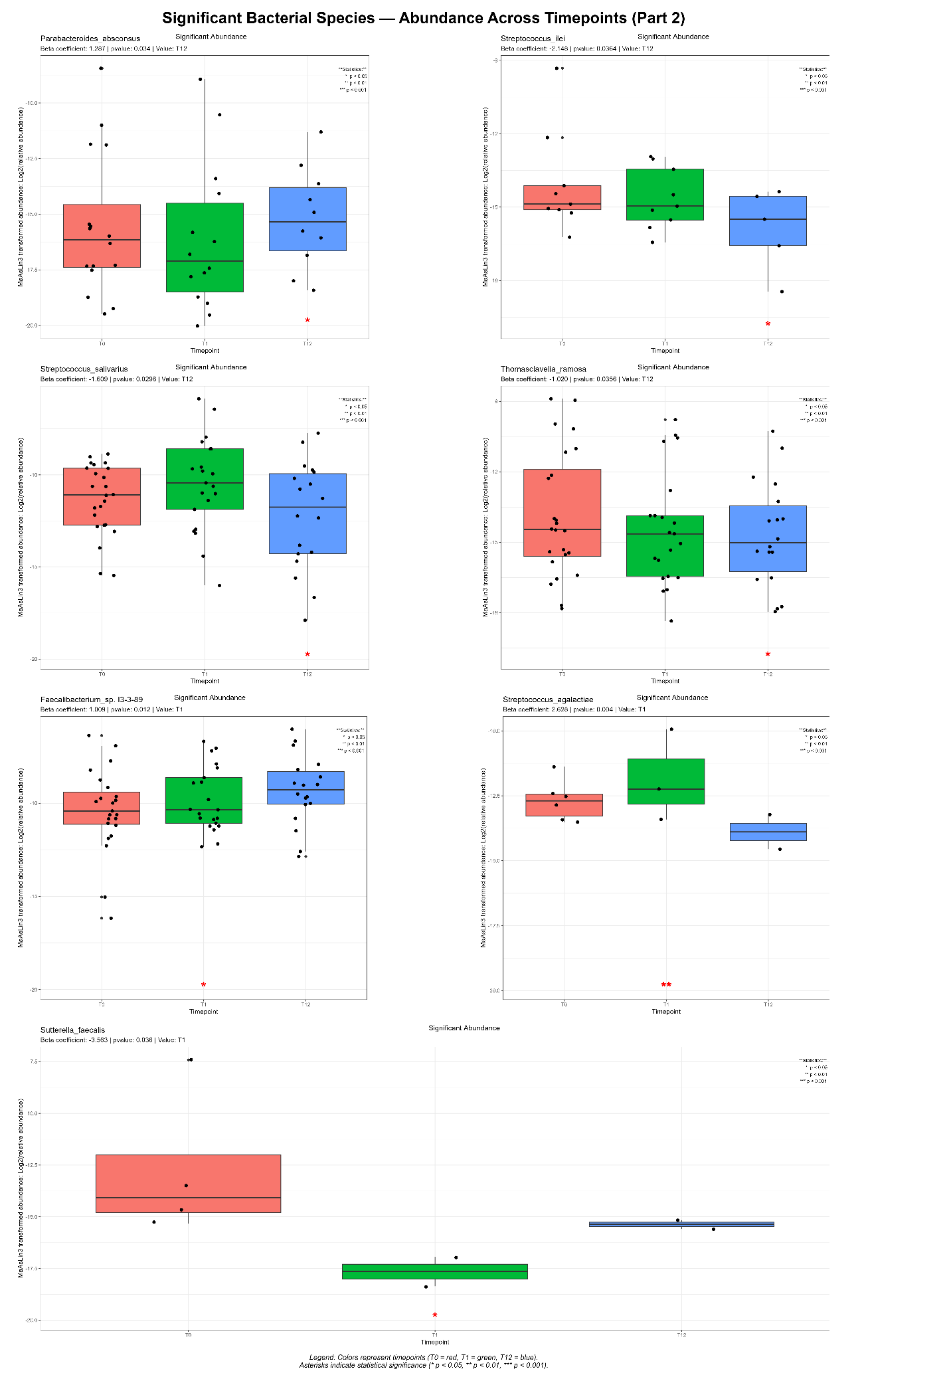
Figure 38 | Significant Bacteria Relative Abundance (part 2)
For Parabacteroides absconsus, a significant increase in abundance is observed at T12 (β = 1.287, p = 0.034), indicating late growth during the follow‑up. The species may be involved in fermentation processes or long‑term immune response.
Streptococcus ilei shows a significant reduction in abundance at T12 (β = −2.148, p = 0.0364), suggesting a progressive decrease over the course of the year. This behavior may reflect an effect of the treatment.
Streptococcus salivarius shows a significant reduction in abundance at T12 (β = −1.609, p = 0.0296). The decrease over time may be associated with a rebalancing of the oral‑intestinal component of the microbiota.
Thomasclavelia ramosa shows a significant reduction in abundance at T12 (β = −1.020, p = 0.0356), confirming a decreasing trend similar to that observed for Thomasclavelia sporiformis. This suggests a common response of this genus to the treatment.
Faecalibacterium sp. I3‑3‑89 shows a significant increase in abundance at T1 (β = 1.009, p = 0.012), indicating an early positive response. Its initial growth may reflect an improvement in microbial stability.
Streptococcus agalactiae shows a significant increase in abundance at T1 (β = 2.628, p = 0.004), suggesting a transient response after the start of treatment. The species then tends to decrease at T12, rebalancing over the long term.
Sutterella faecalis shows a significant reduction in abundance at T1 (β = −3.563, p = 0.036), highlighting an early decline. Its decrease may represent a beneficial effect of the treatment.
In summary, several taxa showed early increases at T1 or late rises at T12, while others exhibited progressive or long-term reductions, indicating distinct microbial responses to treatment and time-dependent.

3.5 MultiConnector

Discussion

References DA METTERE IN ORDINE ALFABETICO
[1] Calliope A. Dendrou , Lars Fugger , Manuel A. Friese. (2015). Immunopathology of multiple sclerosis. Nature Reviews Immunology. 10.1038/nri3871

[2] Jorge Correale, Reinhard Hohlfeld, Sergio E. Baranzini. (2022). The role of the gut microbiota in multiple sclerosis. Nature Reviews Immunology. 10.1038/s41582-022-00697-8.

[3] Alessandro Maglione, Rachele Rosso, Dora Tortarolo, Francesco Pantini, Simone Pernice, Sandro Gepiro Contaldo, Roberta Lanzillo, Antonio Luca spiezia, Cinzia Cordioli, Eleonora Virgilio, Federica Masuzzo, Manuela Matta, Simona Malucchi, Paola Cavalla, Luca Cocolin, Roberta Sirovich, Marco Beccuti, Ilario Ferrocino, Francesca Cordero, Marinella Clerico, Simona Rolla. (2026). Gut microbiome profiling at multiple sclerosis onset as a potential early prognostic marker of disease course: evidence from an observational cohort study.

[4] Melanie Ward, Myla D Goldman. (2022). Epidemiology and Pathophysiology of Multiple Sclerosis. CONTINUUM: Lifelong Learning in Neurology. 10.1212/CON.0000000000001136.

[5] Sylvia Klineova, Fred D Lublin. (2018). Clinical Course Of Multiple Sclerosis. Cold Spring Harb Perspect Med. 10.1101/cshperspect.a028928.

[6] Fred D Lublin, Dieter A Häring, Habib Ganjgahi, Alex Ocampo, Farhad Hatami, Jelena Čuklina, Piet Aarden, Frank Dahlke, Douglas L Arnold, Heinz Wiendl, Tanuja Chitnis, Thomas E Nichols, Bernd C Kieseier, Robert A Bermel. (2022). How patients with multiple sclerosis acquire disability. Brain. 10.1093/brain/awac016.

[7] Moein Amin, Carrie M Hersh. (2023). Updates and advances in multiple sclerosis neurotherapeutics. Neurodegener Dis Manag. 10.2217/nmt-2021-0058.

[8] Emeran A Mayer, Karina Nance, Shelley Chen. (2022). The Gut-Brain Axis. Annu Rev Med. 10.1146/annurev-med-042320-014032.

[9] Silvy Pilotto, Magdalena Zoledziewska, Giuseppe Fenu, Eleonora Cocco, Lorena Lorefice. (2023). Disease-modifying therapy for multiple sclerosis: Implications for gut microbiota. Multiple Sclerosis and Related Disorders. 10.1016/j.msard.2023.104671

[10] Ilaria Del Negro, Sara Pez, Salvatore Versace, Alessandro Marziali, Gian Luigi Gigli, Yan Tereshko, Mariarosaria Valente. (2023). Impact of Disease-Modifying Therapies on Gut–Brain Axis in Multiple Sclerosis. Medicina (Kaunas). 10.3390/medicina60010006

[11] Gavin Giovannoni, Joela Mathews. (2022). Cladribine Tablets for Relapsing-Remitting Multiple Sclerosis: A Clinician's Review. Neurol Ther. 10.1007/s40120-022-00339-7

[12] Óscar Fernández, Gavin Giovannoni, Robert J Fox, Ralf Gold, J Theodore Phillips, James Potts, Macaulay Okwuokenye, Jing L Marantz. (2017). Efficacy and Safety of Delayed-release Dimethyl Fumarate for Relapsing-remitting Multiple Sclerosis in Prior Interferon Users: An Integrated Analysis of DEFINE and CONFIRM. Randomized Controlled Trial. 10.1016/j.clinthera.2017.06.012

[13] Céline Elie, Magali Perret, Hayat Hage, Erwin Sentausa, Amy Hesketh, Karen Louis, Asmaà Fritah-Lafont, Philippe Leissner, Carole Vachon, Hervé Rostaing, Frédéric Reynier, Gaspard Gervasi, Adrien Saliou. (2023). Comparison of DNA extraction methods for 16S rRNA gene sequencing in the analysis of the human gut microbiome. Scientific Reports. 10.1038/s41598-023-33959-6

[14] John F. Kurtzke. (1983). Rating neurologic impairment in multiple sclerosis: An expanded disability status scale (EDSS). Neurology. 10.1212/WNL.33.11.1444

[15] Francesco Sofi, Claudio Macchi, Rosanna Abbate, Gian Franco Gensini and Alessandro Casini. (2013). Mediterranean diet and health status: an updated meta-analysis and a proposal for a literature-based adherence score. Public Health Nutrition.10.1017/S1368980013003169

[16] Evangelia Makrina Dimitriadou, Dimitrios Tzanetakos, Aikaterini Theodorou, Alexandra Akrivaki, Dimitrios Papadopoulos, Vasileios Mastorodemos, Aleksandra Maleska, Stefania Alexia Sotirli, Nikolaos Fakas, Christos Stergiou, Dimitrios Kitsos, Vasileios Giannopapas, Christos Moschovos, Sotirios Giannopoulos, Jens Kuhle, Georgios Tsivgoulis, John S. Tzartos. (2026). The predictive value of serum neurofilament light chain in achieving no evidence of disease activity-3 (NEDA-3) status in treatment-naïve patients with multiple sclerosis. Journal of Neurology. 10.1007/s00415-026-13709-0

[17] Salil Vasudeo Deo & Vaishali Deo & Varun Sundaram. (2021). Survival analysis—part 2: Cox proportional hazards model. Indian Journal of Thoracic and Cardiovascular Surgery. 10.1007/s12055-020-01108-7

[18] Simone Pernice, Roberta Sirovich, Elena Grassi, Martina Ferri, Francesco Sassi, Luca Alessandrı, Dora Tortarolo, Raffaele A. Calogero, Marco Viviani, Livio Trusolino, Andrea Bertotti, Marco Beccuti, Martina Olivero, Francesca Cordero. (2023). CONNECTOR, fitting and clustering of longitudinal data to reveal a new risk stratification system. Bioinformatics. 10.1093/bioinformatics/btad201

[19] D.E. Wood, J. Lu, B. Langmead. (2019). Improved metagenomic analysis with Kraken 2. Genome Biology. 10.1186/s13059-019-1891-0.

[20] I. Ferrocino, et al. (2018). Changes in the gut microbiota composition during pregnancy in patients with gestational diabetes mellitus (GDM). Sci Rep. 10.1038/s41598-018-30735-9.

[21] H. Li, R, Durbin. (2009). Fast and accurate short read alignment with Burrows-Wheeler transform. Bioinformatics. 10.1093/bioinformatics/btp324.

[22] R. J. Wright, A. M. Corneau, M. G. I. Langille. (2023). From defaults to databases: parameter and database choice dramatically impact the performance of metagenomic taxonomic classification tools. Microbial Genomics. 10.1099/mgen.0.000949.

[23] J. Lu, et al. (2022). Metagenome analysis using Kraken software suite. Nat Protoc. 10.1038/s41596-022-00738-y

[24] P. J. McMurdie, S. Holmes. (2013). Phyloseq: An R Package for Reproducible Interactive Analysis and Graphics of Microbiome Census Data. PLOS ONE. 10.1371/journal.pone.0061217

[25] M. I. Love, W. Huber, S. Anders. (2014). Moderated estimation of fold change and dispersion for RNA-seq data with DESeq2. Genome Biol. 10.1186/s13059-014-0550-8

[26] W. A. Nickols, et al. (2026). MaAsLin 3: refining and extending generalized multivariable linear model for meta-omic association discovery. Nat Methods. 10.1101/2024.12.13.628459

[27] F. Beghini, et al. (2021). Integrating taxonomic, functional, and strain-level profiling of diverse microbial communities with bioBakery 3. eLife. 10.7554/eLife.65088

[28] B. Buchfink, C. Xie, D. H. Huson. (2015). Fast and sensitive protein alignment using DIAMOND. Nat Methods. 10.1038/nmeth.3176

[29] B. E. Suzek, H. Huang, P. McGarvery, R. Mazumder, C. H. Wu. (2007). UniRef: comprehensive and non-redundant UniProt reference clusters. Bioinformatics. 10.1093/bioinformatics/btm098

[30] Tommaso Guerra, Antonella Bianco, Chiara Esposto, Donata Intini, Fabio Amati, Giuseppe Guglielmini, Francesca Caputo, Damiano Paolicelli, Pietro Iaffaldano. (2026). Refining predictors of long-term NEDA-3 status in relapsing-remitting multiple sclerosis: insights from real-world data. Neurological Sciences. 10.1007/s10072-026-08876-x

[31] Pegah Rasoulian, Camellia Akhgarjand, Hirad Houjaghani, Homa Seyedmirzaei, Mehrangiz Zangeneh, Khashayar Danandeh, Babak Goodarzy, Nima Mohsenzadeh Kermani. (2025). Gut dysbiosis in multiple sclerosis patients: a comparative analysis in fecal samples. Scientific Reports. 10.1038/s41598-025-19998-1
[32] Alicia Sanchez-Sanz and Sergio E. Baranzini. (2026). The Gut Microbiome in Multiple Sclerosis. Neurol Neuroimmunol Neuroinflamm. 10.1212/NXI.0000000000200638

[33] Sudeep Ghimire, Peter C. Lehmana, Leeann S. Aguilar Mezad, Shailesh K. Shahia, Jemmie Hoange , Heena Olalde, Mishelle Paullus, Catherine Cheerwine, Kai Wang , Christine Gillf, Tracey Chof, Ashutosh K. Mangalam. (2025). Specific microbial ratio in the gut microbiome is associated
with multiple sclerosis. PNAS: Immunology and Inflammation. 10.1073/pnas.2413953122

[34] María-Teresa García-Conesa, Elena Philippou, Christos Pafilas, Marika Massaro, Stefano Quarta, Vanda Andrade, Rui Jorge, Mihail Chervenkov, Teodora Ivanova, Dessislava Dimitrova, Viktorija Maksimova, Katarina Smilkov, Darinka Gjorgieva Ackova, Lence Miloseva, Tatjana Ruskovska, Georgia Eirini Deligiannidou, Christos A. Kontogiorgis and Paula Pinto. (2020). Exploring the Validity of the 14-Item Mediterranean Diet Adherence Screener (MEDAS): A Cross-National Study in Seven European Countries around the Mediterranean Region. Nutrients. 10.3390/nu12102960 AL POSTO DEL [15]

